DRY REFORMING OF HYDROCARBONS

BY

YATISH T. SHAH

AND

TODD GARDNER

Dry Reforming of Hydrocarbons

TABLE OF CONTENTS

Section Title Page

1. Introduction
1.A. Dry reforming and “oxy forming” of methane
1.B. Thermodynamics of dry reforming of methane
1.C. Scope of chapter

2. Mechanism, Kinetics and Catalysis of Dry Reforming of Methane
2.A. Nobel and transitional metal catalysts
2.B. Composite catalysts
2.C. Effects of supports and promoters

3. Mechanism, Kinetics and Catalysis of Dry Reforming of Higher Hydrocarbons and Alcohol

4. Process Considerations
4.A. Issues
4.B. Recent development on Potential Applications
4.C. Heat Optimization
4.D. Supercritical oxidation of hydrocarbons

5. Concluding Remarks and Recommendations

6. Acknowledgement

7. References

1. INTRODUCTION

In recent years, significant interest in carbon dioxide removal has been displayed because of the necessity to fight the greenhouse effect by monitoring the carbon emission in the atmosphere and to effectively use all limited carbon raw material sources for the chemical industry. This chapter reviews our present state of knowledge for one method namely “dry reforming” to convert carbon dioxide in useful raw materials for chemical and fuel industry.

Carbon dioxide is generated in many fuel production and refining industries. The fossil fuel (oil, coal, tar sands, bitumen, heavy oil, shale oil, etc.) transformation to either transportation fuel (such as gasoline and diesel oil) or power generation produces significant amounts of carbon dioxide. The future environmental regulations would require either to separate this CO₂ and sequester it or to transform it into more useful chemical products.

The chemical transformation of carbon dioxide involves a) supplying energy by light or electricity or using high energy feed materials such as hydrogen, unsaturated hydrocarbons etc. such a transformation generates products such as carboxylic acid, esters, lactone among others, b) increasing forward reaction rate by selectively removing a product e.g. removing water during gas shift reaction, or c) targeting low energy products such as organic carbonates and carbonations. Various types of CO₂ transformation reactions that are possible are described in Table 1(108). The present review focuses on the transformation of CO₂ by dry reforming reactions.

Reaction paths and possible products for CO₂ transformation (after Sakakura et al.(108))
Reaction Path | Typical Products
Chemical-non hydrogenative | carbonates, carbamates etc.
Chemical-hydrogenative | hydrocarbons, methanol, ethanol etc.
Photochemical | CO, HCO₂H, CH₄
Inorganic | carbonates: M₂CO₃
Biological | EtOH, sugar, CH₃CO₂H
Electrochemical | CO, HCO₂H, MeOH
Reforming | CO, H₂, hydrocarbons, H₂O
Target for the present review | CO, H₂, hydrocarbons, H₂O
Table 1

The dry reforming of gaseous hydrocarbons by carbon dioxide has significant commercial potential. Hydrocarbon streams containing CO₂ are plentiful in hydroprocessing operations. One example is the off-gases from F-T process for making the transportation fuel. Hydrocarbons are generally inexpensive and the process of transforming hydrocarbons by CO₂ is generally known as dry-reforming. This paper critically reviews our present state of art for the dry reforming of hydrocarbons with special emphasis on the dry reforming of methane.

There are at least two examples of the commercial process for the dry reforming of methane. The industrial caloric process, which has been developed using nickel-based catalysts, for the production of CO-rich synthesis gas from methane and a large excess of CO₂; pure carbon monoxide is an important chemical feedstock, for example, in the production of acetic acid and phosgene. This multi-stage process was developed by Caloric Gmbh. In the first stage of the process, carbon dioxide and methane are reacted together producing a mixture of carbon monoxide, hydrogen, carbon dioxide, and water. The heat for the endothermic reaction is provided by burning of fuel in a similar manner to the steam-reforming process. In the next stage, the carbon dioxide in the effluent stream is removed and recycled to the reformers. The carbon monoxide is separated from the hydrogen (which can be used as a fuel and sold) and methane leaving only a very small amount of methane hydrocarbons remaining in the product stream and giving purities up to 99.95%. The dry reforming of methane has also been practiced by the SPARG (Sulfur Passivated Reforming) process (58, 59) although the industrial reformers have tended to operate with a mixture of CO₂ and H₂O.

1. A Dry reforming versus other methods of methane emersion

While this review is largely restricted to the dry reforming of methane, it is worthwhile to
briefly assess various types of Red ox processes for the methane which can be collectively identified as the ‘oxy-forming’ process (60). The relevant reactions for this oxy-forming process are

CH₄ + H₂O→CO + 3H₂ | ∆H˚_{298k} = +206kJmole⁻¹ | (1) | (Steam reforming)
CH₄ + CO₂→2CO + 2H₂ | ∆H˚_{298k} = +247kJmole⁻¹ | (2) | (Dry reforming)
CH₄ + O₂→CO + 2H₂ | ∆H˚_{298k} = -38kJmole⁻¹ | (3) | (Partial oxidation)
CO + H₂→CO + H₂O | ∆H˚_{298k} = -41kJmole⁻¹ | (4) | (Reverse water gas shift reaction)

Table 1 Summary of recent studies of carbon dioxide reductions by hydrocarbons
Author | Title | Catalyst | Temperature  °C | Pressure  (atm) | Remarks
Barrai et al. (6) | The role of carbon deposition in previous metal catalyst activity during dry reforming of biogas | 0.5% Pt/gamma on Al₂0₃ catalyst | 900 °C | 1 atm | At high temperatures, 24% increase in catalyst weight due to carbon deposition. Increased wt. gain at higher temperature due to possible Boudard reaction at high temperatures. At high C0₂, catalyst activity was maintained
Raberg et al. (7) | Propane dry reforming over Ni-based catalyst. Influence of support and operating conditions | Ni (2%)/Si0₂ or A1₂0₃ ox Mg(Al)O | 600 °C | 1 atm | Mg(Al)O was the best support. Gave most dispersed Ni particles.
Arishtirova et al. (8) | Promoting effect of Pt on Ni-based catalysts for CH4 reforming | Pt (0.3-0.5 wt%) on Ni catalysts. Pt Ni catalyst on NaZSM-5 catalyst amount of Ni 6wt% | 500 °C | 1 atm | Better distribution of Ni with addition of Pt
Dominquez et al. (9) | Biogas to syngas by microwave assisted dry reforming in the presence of char | Rich potassium char obtained from biomass pyrolysis | 800 °C | 1 atm | The presence of CO₂ increased the conversion of CH₄ to H₂, the values being higher in MWH than in EH. MWH produced high quality syngas
Mhadeshwar and Vlachos (10) | A catalytic reaction mechanism for methane partial oxidation at short contact times, reforming and combustion and for oxygenate decomposition and oxidation on platinum | Pt |  | 1 atm | Microkinetic model for partial Oxidate, reforming and combustion
Eriksson et al. (11) | Effect of Ce doping on Rb/Zr02 catalysts for partial oxidation of methane | Rh/ZrO₂ CeO₂-ZrO |  | 1 atm | Light-off temperature decreased by 128 °C while using Ce02-Zr02 support
Yin et al (12) | Simulation of effect of catalyst particle cluster in dry methane reforming in circulating fluidized bed | Rh/A1₂O₃ | variable | variable | The effect if catalyst particle clusters on dry reforming in circulating fluidized bid reformers is considered. The effect of gas temperature and inlet gas velocity and reactor pressure on reforming reactions were investigated.
Guo et al. (13) | The deposition of coke from methane on a NiIMgAl2O4 catalyst | 0.5 Ni/MgA1₂O₄ | 750 °C | 1 atm | Initiation of the carbon ‘bum-off’ reaction temperature increased from 273 to 378 °C when MgAl₂O₄ replaced the catalyst support gamma-A1₂0₃

Sun et al (14) | Preparation  Ni-titanium composite xerogel catalyst for CO₂ reforming of CH₄ | Ni-Ti composite xerogel catalyst |  | 1 atm | Ni-Ti-Al composite xerogel had high surface area. The optimum hydrolysis ratio and acid/alkoxide ratio were determined; calcination temperature from 453 to 973 K
Galaktinova et al (15) | Formation of compaction products in methane dry reforming on Ni- containing catalyst | Ni₃A1 catalyst | 600-950 °C | 1 atm | Despite the formation of compaction products at the catalyst surface, the initial porous structure of the sample is retained
Bouka, et al (16) | Methane dry reforming on Ni-loaded hydroxyapatite and fluroapatite | Ni on Ca-hydroxyapatite and Ca-fluroapatite | 600 °C | 1 atm | CH₄/C0₂/He  Carbon deposition increased with  Ni loading
Pechimuthu (17) | Deactivation studies over Ni-KJCeO2-A1203 catalyst for dry reforming of methane | Ni-KJCeO₂-A1₂0₃ | 650-750 °C | 1 atm | CH₄/C0₂/H₂  13.5 Ni-2K/10 Ce0₂-A1₂O₃  exhibited very stable catalyst performance. The activation energy for coke oxidation ranged between 110-560 kJ/mole. The catalyst exhibited stable operation above 650 °C without coke effects
Topilidis et al (18) | A kinetic study of methane and carbon dioxide dioxide interconversion over 0.5% Pt/SrTiO3 catalyst | .05% Pt/SrTiO₃ | 540-620 °C | 1 atm | P_{ch4} > .083  P_{co2} > .667  R_{ch4} = k(P_{ch4)} ^{0-0.3} (P_{co2})^{3-.6} proposed. Activation energy is  ~ 123 kJ/mole
Promaros et al. (19) | Carbon dioxide reforming of methane under periodic operations | Ni/SiO₂ · MgO catalyst | 650-750 °C | 1 atm | Cycle period and cycle split did not influence the reaction performance within the ranges of this study
Munera et al. (20) | Kinetics and reaction pathways of CO₂ reforming if methane on Rh-supported on lanthanum-based solid | Rh/La₂O₃ | 550-630 °C | 2.5-40 kPa | A kinetic expression is derived for the data
Cui et al. (21) | Kinetic study of the catalytic reforming of CH₄ with CO₂ to syngas over Ni/α-Al₂O₃ catalyst; the effect of temperature on the reforming mechanism | Ni/α-Al₂O₃ | 550-750 °C | 1 atm | The reaction temperature remarkably influences the reforming mechanism through altering the reaction steps
Murata et al. (22) | Improved of lifetime of Ni/merdenite catalysts for CO₂ reforming of methane by support modification with alumina and Co-K loading | Ni/H-mordenate  Ni-Co-K/HM-Al₂O₃ | 650-700 °C | 1 atm | High activity of new catalyst at 700 °C for more than 300 hrs
Haag et al. (23) | Beneficial effect of the use of Ni membrane reactor for the dry reforming of methane; comparison of thermodynamic predictions | Ni-CO/Al₂O₃ catalyst (Ni composite membrane) | 450-550 °C | 1 atm | CH₄/CO₂ = 1:1  10% CO₂  10% CH₄  80% N₂
Goula et al. (24) | Catalytic and electrocatalytic behavior of Ni-based cermet anodes under internal dry reforming of CH₄ + CO₂ mixture in SOFCs | SOFC with yttria stabilized zirconia (Ni-YSZ) | 850 °C  700-900 °C | 1 atm | CO₂/CH₄  1/1
Pelletier and Liu (25) | Stable nickel catalysts with alumina-aluminum phosphate supports for partial oxidation and carbon monoxide reforming of methane | Alumina-aluminum phosphate (AAP)  AAR impregnated nickel catalysts with gamma Al₂O₃ and AAP supports | - | 1 atm | Impregnated nickel with both gamma-Al₂O₃ and AAP supports deactivated quickly. Co-precipitated nickel catalysts show no sign of deactivation
Pompeo et al. (26) | Study of Ni and Pt catalysts supported on alpha-Al₂O₃ and ZrO₂ applied in methane reforming with CO₂ | Ni and Pt catalysts supported on alpha-Al₂O₃-ZrO₂ and ZrO₂ | - | 1 atm | Pt/ZrO₂, Pt/alpha-Al₂O₃-ZrO₂, and Ni/alpha-Al₂O₃-ZrO₂ systems show lower deactivation than Ni/ZrO₂ and Ni or Pt catalysts supported on alpha-Al₂O₃. The lowest deactivation levels observed in Ni and Pt supported on alpha-Al₂O₃-ZrO₂ compared with Ni and Pt supported on alpha-Al₂O₃
Goncalves et al. (27) | Preparation of and characterization of nickel-based catalysts on silica, alumina, and titania obtained by sol-gel method | Catalysts produced by sol-gel processes. Ni on alumina-, silica-, and titania-based materials | - | 1 atm | Surface area:  NiSiO₂ > Ni-Al₂O₃ > Ni-TiO₂  Temperature programmed reactions were performed
Yokota et al. (28) | Strong inhibition effect of sulfur impurities in alumina supports on the catalytic activity of Rh in the CH₄-CO₂ reforming reaction | S-NiO reduced to Ni | 780 °C | 1 atm | CH₄ conversion over S-NiO was superior to that over regent NiO (γ-NiO). The difference in catalyst activity between S-NiO and γ-NiO were examined in terms of carbon deposition and the sinterability of samples
Nagayasu et al. (29) | Effect of carbon dioxide co-feed on decomposition of methane over Ni catalysts | Ni-catalysts | - | 1 atm | TG apparatus used gasification of the carbon species with carbon dioxide and water gas shift reactor took place simultaneously
Choudhary et al. (30) | Methane reforming over a high temperature stable -- NiCOMgO_{x} supported on zirconia-hafnia catalyst | NiCOMgO_{x} (Ni/CO/Mg) (1/0.2/1.2) zirconia-hafnia catalyst | 900 °C | 1 atm | Stable catalyst at high temperatures suitable for adiabatic conditions -- CO and H₂ selectivity decrease with increasing space velocity
O'Connor et al. (31) | Transient studies of CO₂ reforming of methane over Pt/ZrO₂ and Pt/Al₂O₃ | Pt/ZrO₂  Pt/Al₂O₃ | - | 1 atm | A reaction sequence for both catalysts is suggested
Olafsen et al. (32) | Light alkanes CO₂ reforming to synthesis gas over Ni-based catalyst (methane and propane reforming) | Ni/SiO2  Ni/Mg(Al)O  hydrotalcite catalyst | variable | 1 atm | Both catalysts more action for methane than propane reforming. Coke production is higher for propane than methane
Shamsi, A. (33) | Partial oxidation and dry reforming of methane over Ca/Ni/K/Na | Ca/Ni/K/Na catalyst | Temperature programmed oxidation | 1 atm | Catalyst consumed significant amount of oxygen. Surface oxygen plays a significant role in oxidizing and removing carbon species from the catalyst surface
Gao et al. (34) | Autothermal reforming and partial oxidation of methane in fluidized-bed rector over highly dispersed Ni catalyst prepared from Ni complex | Ni catalyst (highly dispersed) on SiO₂ | 800 °C | 1 atm | Highly dispersed and using only sized Ni crystallites were more stable and more reactive for both auto thermal reforming and partial oxidation of methane in a fluidized-bed reactor
De Lima et al. (35) | Structural features of La|-xCe_{x}NiO₃ mixed oxides and performance for the dry reforming of methane | Mixed oxides  La_{1-x}Ce_{x}NiO₃ (x = 0, 0.05, 0.4, and 0.7) | 750 °C | 1 | La_{0.95}Ce_{0.05}NiO₃ catalyst showed highest activity. At high Ce contents, ceria appears as segregated C_{e}O₂ phase and interferes with the rate of perovskite structure formation so that NiO and L_{a}2NiO₄ are produced
Hou et al. (36) | Production of synthesis gas via methane reforming with CO₂ on noble metals and small amount of noble- (Rh-) promoted Ni catalysts | (Ru, Rh, Pt, Pd, Ir, No, Co) metals supported catalysts (5 wt% loading) on Al₂O₃ | - | 1 | Catalyst showed high coke resistability. Activity was lower than that of Ni and Co (10 wt% loading amount). Dispersion of cut (Rh) depended strongly upon loading amount and surface area of support. Rh dispersed highly on men-porous Al₂O₃ (with high surface area). Small amount of Rh increased significantly both reforming and coke resistance activity
Djaidja et al. (37) | Characterization and activity in dry reforming of methane on Ni/Mg/Al and Ni/MgO catalysts | Co-precipitator catalyst  n(Ni_{x}Mg_{y})/Al, Ni_{x}-Mg_{y} and Ni_{x}Al_{y} or NiMgO (mole % Ni = 5, 10) | 800 °C | 1 | Bimetallic catalysts NiO_{.05}Mg_{0.95} presents poor activity. 5% Ni/MgO catalyst having same composition show higher activity. Activity decreased with an increase in calcination temperature
Sahli et al. (38) | Ni catalysts from NiAl₂O₄ spinel for CO₂ reforming of methane | Mixed oxides closed to NiAl₂O₄ by sol-gel like method | - | 1 | Optimum Ni/Al was 0.5. A solid solution is obtained for Ni/Al less than 0.5. The spinel structure is non-tolerant concerning a change of Ni/Al ratio greater than 0.5
Jiang et al. (39) | GDC-impregnated (La_{0.75}Sr_{0.25}) (Cr_{0.5}Mn_{0.5})⁰⁻³ anodes for direct utilization of methane in solid oxide fuel cells | Gd-coped ceria (GDC) impregnated (La_{0.75}Sr_{0.25}) (Cr_{0.5}Mn_{0.5})_{0.3} (LSCM) in solid oxide fuel cells. Alternative to Ni-free anode | 800 °C | 1 | The polarization performance of GDC-impregnated LSCM was substantially higher than that of pure LSCM and LSCM/YSZ composite anodes
Munera et al. (40) | Kinetic studies of the dry reforming of methane over the Rh/La₂O₃-SiO₂ catalyst | Rh (0.6%)/La₂O₂ (27%)-SiO₂ | variable | 1 | Best catalysts for membrane reactor. Several instrumental techniques (TPD, DRIFIS, and XPS) were examined. Kinetic behavior of catalysts as function of temperature and partial pressure of CH₄ and CO₂ examined. The rate dependence on partial pressures (both) show fractional orders. Kinetic equation proposed. Methane consumption depends on fractional order dependence on both CH4 and CO2. Better catalysts than Rh or La-containing oxides
Paturzo et al. (41) | A Pd/Ag tubular membrane reactor for methane dry reforming: a reactive method for CO₂ consumption | Pd/Ag membrane reactor | 350-450 °C | 1 | Membrane reactor
Kang et al. (42) | Nickle-based tri-reforming catalysts for production of synthesis gas | NiO-YSZ-CeO₂ catalyst | variable | 1 | Tri-reforming was more favorable than dry reforming. MiO-YSZ-CeO₂ catalyst was more active and stable than Holder Topsoe (HT) and ICI catalysts in tri-reforming of CH₄
Quiroga and Lana (43) | Kinetic analysis of rate data for dry reforming of methane | Ni-Rh-Al₂O₃ catalyst | variable | 1 | 27 mechanistic models were considered. A thermo analysis showed that the reverse water gas shift reaction operates in a very close thermodynamic equilibrium. CO₂ molecular adsorption, CH₄ dissociative adsorption and its surface chemical reaction as the rate limiting step
Pawelec et al. (44) | Structural and surface features of PtNi catalysts for reforming of methane with CO₂ | Pt (1-12 wt%) on bimetallic PtNi catalysts supported on ZSM-5 | variable | 1 | Pt addition causes the formation of small nano-sized particles and easy reduction of NiO. The improvement of catalyst activity and stability was attributed to increase in nickel metallic dispersion caused by an intimate contact of Ni and Pt at Ni loading of 6%
Rezaei et al. (45) | Mesoporous noncrystalline zirconia powders: a promising support for nickel catalyst in CH₄ reforming with CO₂ | Mesoporous noncrystalline zirconia powders (ZrO₂-3% M₂O_{x} : M : C, La and K) with high surface area with Ni | variable | 1 | Good catalyst for dry reforming. Use of plutonic P/23 block co-polymer surfactant
Rezaei et al. (46) | CO₂ · CH₄ reforming over Ni catalysts supported on mesoporous nanocrystalline zirconia with high surface area | 15 % Ni/ZrO₂ and addition of CeO₂ | variable | 1 | 5% Ni/ZrO₂ catalyst exhibited stable activity. The addition of cerium oxide to nickel improved its stability and decreased coke production
Faroldi et al. (47) | Production of ultrapure H₂ in a Pd-Ag membrane reaction using Ru/La₂O₃ catalyst | Ru/La₂O₃ catalyst  Ru (0.6 wt%) and Ru (1.2 wt%) | variable | 1 | Ru (0.6) and Ru (1.2) improved the catalytic ability to restore equilibrium. Ru strongly interacts with La
Yentekakis, L. V. (48) | Open and closed circuit study of an intermediate temperature SOFC directly fueled with simulated biogas mixtures | Solid oxide fuel cell (SOFC) based on gadolinia-doped ceria (GDC) solid electrolyte, a Ni(Au)-GDC cermet anode and a La_{0.54}Sr_{0.46} MnO₃ | 600 , 640 °C | 1 | The catalytic (open circuit) rate of the methane dry (CO₂) reforming reaction over Ni(Au)-GDC anode was found to be maximized at absent equimolar CH₄/CO₂ feed ratio
Assabumrungrat et al. (49) | Determination of the boundary of carbon formation for dry reforming of methane in a solid oxide fuel cell | Direct internal reforming solid oxide fuel cells (DIR-SOFCs) with different types of electrodes | T > 727 °C | 1 | The type of electrolyte influenced the boundary of carbon formation because it determined the location of water formed by the electro chemical reaction. The extent of electrochemical reaction also played an important role in the boundary of carbon formation
Puolakka et al. (50) | Combined CO₂ reforming and partial oxidation of n-heptane on noble metal zirconia catalysts | Various noble metals supported on zirconia catalysts Rh > Pd > Ir > Pt | 700-900 °C | 1 | The activity and selectivity of the 0.25 wt% Rh/ZrO₂ catalyst were close to the performance of a commercial 15 wt% NiO/Al₂O₃ catalysts. The conversion and production compositions were compared to the calculated thermodynamic equilibria
deLima and Assaf (51) | Ni-Fe catalysts based on perovskite-type oxides for dry reforming of methane to syngas | LaNi_{1-x}Fe_{x}O₃ (x = 0, 0.2, 0.4, and 0) perovskite catalyst partial substitute of nickel by iron | Variable | 1 | The partial substitution of Ni by Fe in the perovskite structure resulted in decreasing rates of conversion of both reactants. However, the stability of the catalyst during the reaction was highly increased
Cellier et al. (52) | Modification of catalytic performance due to the cofeeding of hydrogen or carbon dioxide in the partial oxidation of methane over a NiO/gamma-Al₂O₃ catalyst | NiO/gamma-Al₂O₃ catalyst | Variable | 1 | The increase of 1-10 wt% H₂ or CO₂ to the feed during partial oxidation of CH₄. The addition of H₂ decreases the conversion of syngas selectivity. The addition of CO₂ decreases H₂ production but increases CO production. A combination of dry reforming and the reverse gas shift reaction causes this effect
DeOliveira-Vigier et al. (53) | Dry reforming of ethanol in the presence of a 316 stainless steel catalyst | Stainless steel catalyst | Variable | 1 | Yield of H₂ can be reached as high as 98% if theoretical value. Co-product C is of filamentous form and can be easily retrieved. The catalyst is recyclable and can be used several times
Juan-Juan et al. (54) | Effect of potassium content in the activity of K promoted Ni/Al₂O₃ catalysts for the dry reforming of methane | K on Ni active phase in the activity and selectivity of the NiK/Al₂O₃ catalysts | 700 °C | 1 | SEM, TEM, PR analysis was carried out. The activity date indicates that the addition of a low amount of potassium (0.2 wt% K₂O) allows to obtain a catalyst with an acceptably high activity and very low coke deposition. The catalyst activity remains almost constant for 24 hrs at different amounts of potassium
Itkulova et al. (55) | CO₂ reforming of methane over Co-Pd/Al₂O₃ catalysts | Bimetallic Co-Pd on Al₂O₃ catalysts | variable |  | The activity, selectivity, stability, and variable resistance to the carbon deposition depend on catalyst composition and process conditions. The catalyst produces the various oxygenate from CO₂ + CH₄ at moderate pressures
Tsyganok et al. (56) | Rational design of Mg-Al mixed oxide supported bimetallic catalysts for dry reforming of methanes. | Synthetic synergy of bimetallic Ru-M (M = Cr, Fe, Co, Ni, and Cu) catalysts supported on Mg-Al oxides | variable | 1 atm | Among all the LDM-derived catalysts a Ru .1%, Mi 5%/MgAl₂O₃ sample revealed the highest activity and selectivity to syngas; a suitable durability and low coking capacity. A promoting effect of Ru on catalytic function of supported Ni was demonstrated
Halmann and Seinfeld (57) | Production of lime, hydrogen, and methanol by thermo-neutral combined calcination of limestone with partial oxidation of natural gas or coal | Dry reforming combined with chemical looping | variable | 1 atm | By combining CO₂-reducing calcination CaCO₃ with CO₂ consuming dry reforming of CH₄ and combining there endothermic reactor with partial oxidation of CH₄ (exothermic reaction). Thermally neutral reaction produces syngas, H₂, and methanol

The first three reactions combined are called ‘oxy-forming’ reactions. The fourth one is the reverse water-gas shift reaction. The first reaction was originally studied by Neumann and Jacobs in 1924. It was subsequently found that many metals such as nickel, cobalt, iron, and the platinum group metals can catalyze reaction (1) to the thermodynamic equilibrium. However, the nickel catalyst has emerged as the most practical catalyst because of its fast turnover rates, long-term stability, and cost. The major technical problem for the nickel catalysts is carbon deposition on the catalysts, via reactions (5) and (6) which can lead to rapid deactivation and breakup of the catalyst:

CH₄→C + 2H₂ | ∆H˚_{298k} = +74.8 kJ/mole⁻¹ | (5)
2CO →C + CO₂ | ∆H˚_{298k} = -172.5kJ/mole⁻¹ | (6)

Carbon deposition could be substantially reduced by the use of an excess of water and a temperature of about 1073K. Other drawbacks of steam reforming are (1) expensive generation of superheated steam (in excess) at high temperature; (2) the production of a significant amount of CO₂ in the product gas via the reverse water-gas shift reaction (4); and (3) the H₂ to CO ratio
is higher than the optimum required for the downstream synthesis gas conversion to methanol, acetic acid, or hydrocarbons.
In the mid 20th century, the partial oxidation of methane to synthesis gas was examined, but with a stoicheometric methane to oxygen ratio used and carbon deposition occurred on the metal catalyst leading to deactivation. Partial oxidation offers some advantages over steam reforming. First, the reaction produces extremely high yields of synthesis gas in an exothermic reaction, and, therefore, the reactor would be more economical to heat. Oxygen is often used in steam reforming to provide heat and high methane conversion. Partial oxidation also gives a better ratio of hydrogen to carbon monoxide for subsequent conversion processes. Thirdly, the product gases from the reaction are low in carbon dioxide which must often be removed before the synthesis gas can be used.

While steam reforming and partial oxidation converts methane to synthesis gas,
dry reforming of methane has the added advantage that it simultaneously consumes two green house gases, hydrocarbons and CO₂. The best reducing agent for CO₂ is hydrogen. As shown by Rozovskii and Lin (61), the synthesis of methanol from CO and H₂ proceeds not by their direct interaction, but by the transformation of CO into CO₂.

CO + H₂O→CO₂ + H₂ | ∆H˚_{298k} = -41.2 kJ/mole⁻¹ | (7)
CO₂ + 3H₂→CH₂OH + H₂O | ∆H˚_{298k} = -49.3 kJ/mole⁻¹ | (8)

Direct utilization of reaction (8) meets opposition because it converts expensive hydrogen into inexpensive water. Thus, CO₂ reductions by hydrocarbons is preferred with lower hydrocarbons and alcohols.

1B. DRY REFORMING OF METHANE
A survey of the literature indicates that dry reforming of methane has been examined with a limited number of catalysts. A critical review of these studies is presented below.

Finally, Aika (68) and Nisheyame and Aika (69) showed that for the PbO-MgO catalyst with moderate basicity, higher C₂-hydrocarbons are produced in the CH₄ + CO₂ + O₂ mixture than in the CH₄ + O₂ mixture. Different catalyst and temperature also resulted in different reactions. Some other possible reactions are:
2CH₄ + CO₂→C₂H₆ + CO + H₂O | ∆H˚_{298k} = +106.1 kJ/mole⁻¹ | (9)
C₂H₆ + CO₂→C₂H₄ + CO + H₂O | ∆H˚_{298k} = +178.2 kJ/mole⁻¹ | (10)
CH₄ + 3CO₂→4CO + 2H₂O | ∆H˚_{298k} = +329.7 kJ/mole⁻¹ | (11)

These reactions compete with the desired reaction (2).

THERMODYNAMICS OF DRY REFORMING OF METHANE

Thermodynamics calculations on the reformate product distribution and carbon formation characteristics were performed using HSC chemistry thermodynamic software (77). Methane was used as the model hydrocarbon compound used in these studies. The effect of pressure,

Propane dehydrogenation by CO₂ produces different sets of reactions depending on the level of conversion as shown below
C₃H₈+CO₂ —> C₃H₆+CO+H₂O (initial) (17)
2C₃H₈ +2C0₂ —>3C₂H₄ +2C0+2H₂0 (selective) (18)
C₃H₈+3CO₂ —> 6CO+4H₂ (deep conversion) (19)

While MgO is one the active and stable catalysts for this reaction (70), other catalysts are discussed later.

With higher hydrocarbons, the reactions become more complex. The possible reactions with n-butane are:

C₄H₁₀ +C0₂ —> 2C₂H₄ +CO+H₂0 (20)
C₄H₁₀ +C0₂ —> C₃H₆ ÷2C0+2H₂0 (21)
C₄H₁₀ + CO₂ —> C₂H₄ + CH₄ + 2C0 + H₂ (22)
C₄H₁₀ +C0₂ —>C₄H₈ +CO+H₂0 (oxidative dehydrogenation) (23)
C₄H₁₀ —>C₄H₈ + H₂ (thermal dehydrogenation) (24)
C₄H₁₀ —>C₃H₆ —>CH₄ (direct cracking) (25)

Depending on the nature of catalyst, n-butane conversions of 81-84% and C₂-C₄ olefin production with the selectivity between 76-78% have been observed at 630-650○C and with n-C₄H₈/CO₂ = 1.2. The selectivity into synthesis gas has been around 22-24% and CO and H₂ are obtained in equal amounts, an observation differs from the CO₂ reactions with ethane and propane. The last reaction in the absence of CO₂ takes place to a very small degree.

As shown in Table 3 the conversion of i-C₄H₁₀ and CO₂ depend upon the nature of the catalyst.

Table 3
i-C₄H₁₀ Conversion) (70-74) at 670○C
Catalyst | i-C₄H₁₀ Conversion | CO₂ Conversion
K-Cr-Mn O/SiO₂ | 30-35% | 5-8%
K-Cr-Mn O/A1₂O₃ | 50% | 9-10%
Cr-Mn-O-A1₂O₃ | 61-66% | 20-29.5%

For all of these catalysts, CO and H₂ were formed in equal amounts, a result substantially different from the ethane and propane conversion where CO/ H₂ ratio was 7-8.
Pretreatment of the catalyst by hydrogen in the reaction conditions does not lead to a decrease of the isobutylene formation selectivity. This is also opposite to the results obtained for ethane and propane conversion. The catalyst pretreatment by CO leads to characteristics of isobutene conversion which are different from those observed for ethane and propane. The reported study (70) also indicates that the main route of the CO formation is the reverse water gas shift reaction.
Since only half of hydrogen formed by reaction (24) is oxidized, the main products for i-C₄H₁₀ dehydrogenation by CO₂ are C₄H₈, CO, and H₂. The side product of propylene selectivity is about 10%.

The oxidative cracking of n-heptane by CO₂ can be described by the general equations:

C₇H₁₆ —C₄H₈+C₃H₆ +H₂ (26)
C₇H₁₆ —> 3C₂H₄ + C + 2H₂ (27)

H₂+C0₂ H₂O+CO (28)
C +C0₂ 2CO (29)

The literature shows (70,74) that the reaction nC₇H₁₆ and CO₂ procedes on the catalysts K-MnO/Al₂0₃, La-MnO/A1₂0₃, and La-MnO/NaY at 540-670 °C. At 670○C, n-heptane conversion was 86.4% for the second catalyst, while it was nearly 100% for the third catalyst. The first two catalysts were more active for CO₂ conversion (30.2% for the second catalyst) while CO₂ conversion for the third catalyst was low (4.2 %). Finally, CO/H₂ ratio for the first two catalysts was about equal, while this ratio for the third catalyst was about 10.

1.B.2 OLEFINIC HYDROCARBONS
Ethylene does not react with CO₂ in the absence of a catalyst. At 750-820 °C, some conversion of C₂H₄ (up to 12%) has been observed with the formation of CH₄, C₃H₆, C₄H₆, and traces of C₄H₈. With nickel catalysts mainly synthesis gas is formed as:
C₂H₄ + 2C0₂ —> 4C0 + 2H₂ (30)
However, Mg and Cr oxides transform ethylene to butadiene and propylene with low CO concentrations. At 850 °C, 17% MnO/Si0₂ catalyst gave (75) C₂H₄ conversion of 22.3%, CO₂ conversion of 11.6%, C₄H₆ selectivity 25%, and C₃H₆ selectivity of 18%. Although the free energy change for the reaction:
2C₂H₄ +C0₂ —> C₄H₆ +CO+H₂ (31)
is positive; nevertheless, CH₄, C₃H₈, and C₄H₈ are also formed. For MnO/SiO₂ catalyst, CO₂ causes decrease in C₄H₆ and C₃H₆ activities and treatment by H₂ causes an increase in selectivity. These results are different from those observed for alkanes.

1.B.3 ALCOHOLS
The reaction between methanol and CO₂ has also been studied for MgO catalyst (72,76): The major reactions are:
CH₃OH+CO₂ —>CH₂O+CO+H₂O (primary) (32)
CH₃OH+2CO₂ —>3C0+2H₂O (33)
CH₃OH —> CH₂O+H₂ (34)
CH₃OH —> CO+3H₂ (35)
Cr-Mo-Mn-O/S_{i}0₂ was found to be an effective catalyst for this reaction. This reaction is particularly difficult because CH₃-OH activation require acidic sites while CO₂ activation requires basic sites. Generally, CO formation requires temperatures higher than 700 °C.
The overall reaction for CO₂ oxidation of ethanol is:
4C₂H₅OH+C0₂ —>2C₄H₆ +CO+H₂ +5H₂0 (36)
Reaction generally occurs at temperature range of 500-600 °C on CuO-MnO/A1₂0₃ catalyst. The products contain C₄H₆, C₄H₈, C₂H₄, CH₄, H₂, CO, and H₂O with C₄H₆, CO, and H₂ as the dominating products. Generally C₂H₅OH conversion of 63%, CO₂ conversion of 16% and CO/H₂ ratio close to one are obtained.

1.B.4 SUMMARY
For C₁-C₇ hydrocarbons and alcohols, the indispensible condition is the selection of a system which adsorbs and activates CO₂. The acidic property of CO₂ necessitates the choice of a catalyst with basic properties. However, alkali metal and alkaline earth oxides are ineffective because of strong carbonate formation. Oxides of a moderate basicity are necessary and moreover, they must participate in redox process with CO₂ reduction. MnO is one example wherein decomposition of MnCO₃ proceeds by the equation:
3MnCO₃ —> Mn₃O₄ + 2C0₂ + CO (37)
Modification of Mn-containing catalyst by other oxides of K, Na, Cr, and La influences both its acceptor function and the degree of surface oxidation. It controls the mechanism of hydrocarbons or alcohol transformations. Possible good candidates are La₂O₃, cesium oxides, and praseodymium oxides. La₂O₃ showed the greatest interactions between CO₂ and hydrocarbons and alcohols.
The mechanism of C₄-C₇ alkane transformation seems to be different from the case of C₁-C₃ alkanes. The general route in the cases of C₁-C₃ alkanes involves dissociation of hydrocarbons and subsequent oxidation of carbon fragments; oxidative dehydrogenation of ethane and propane proceeds also partially. The catalysts are in a more reduced state, the activation of the hydrocarbon is the rate-controlling step. In the case of C₄-C₇ alkanes, the first step of the process is direct hydrogenation of alkanes. Activation of C0₂, but not the activation of hydrocarbon is the rate-controlling step. The hydrogen formed interacts with CO₂ and shifts the equilibrium of the dehydrogenation reaction.

Table 2. Conversion of Ethane with CO₂ at 800 °C, V =
3622 h-1, CO:C₂H₆ = 1.5:1 (v/v) (70)
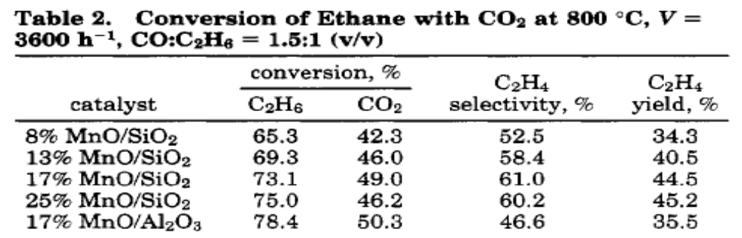

1.C THERMODYNAMICS CO₂ REDUCTION BY METHANE
Thermodynamic calculations on the reformate product distribution and carbon formation characteristics were performed using HSC chemistry thermodynamic software (77). Methane was used as the model hydrocarbon compound used in these studies. The effect of pressure, temperature, the C0₂/CH₄ ratio and the addition of steam were assessed. The equilibrium amount of each species formed was normalized on the basis of one kmol of carbon fed as fuel (i.e. CH₄).
The effect that pressure has on carbon formation and product distribution for the dry
reforming of methane at a C0₂:CH₄ ratio of 1:1 and a temperature of 900 °C is shown in Figure 1. The conversion of methane is complete at pressures below 3 bar and steadily declines to 50% at a pressure of 70 bar. Thermodynamically, carbon formation decreases with increasing pressure. The H₂ yield declines by 50% which is more significant than the decline in CO yield over this pressure range. The selectivity toward combustion products, CO₂ and H₂0, increases marginally over this pressure range.

Figure 2 shows the effect of temperature on the dry reforming of methane over a temperature range of 500 to 1100 °C, at a constant C0₂:CH₄ ratio of 1:1 and a constant pressure of 20 bar. Methane conversion was shown to increase with increasing temperature over this range which corresponds to the increasing H₂ and CO yields. The propensity toward carbon formation is also reduced with increasing temperature. The selectivity toward combustion products, H₂O and CO₂, also diminishes with increasing temperature.
The effect that changing the CO₂:CH₄ ratio at a constant temperature of 900 °C and a constant pressure of 20 bar has on carbon formation and product distribution is shown in Figure 3. Thermodynamically, carbon formation is reduced and CH₄ conversion is increased by
increasing the CO₂:CH₄ ratio. The selectivity toward combustion products, CO₂ and H₂0, remains approximately the same while H₂ and CO product yields are increased.
The effect of steam addition, H₂0:CH₄ (1:1), to the dry reforming reaction, C0₂:CH₄ (1:1) at a constant pressure of 20 bar is given in Figure 4. The addition of steam produces the effect of increasing both the H₂ and CO₂ yields while the propensity toward forming carbon is decreased. CH₄ conversion was similar at all temperatures between dry reforming and dry reforming with steam which suggests that the additional hydrogen production was due to the water gas shift reaction.
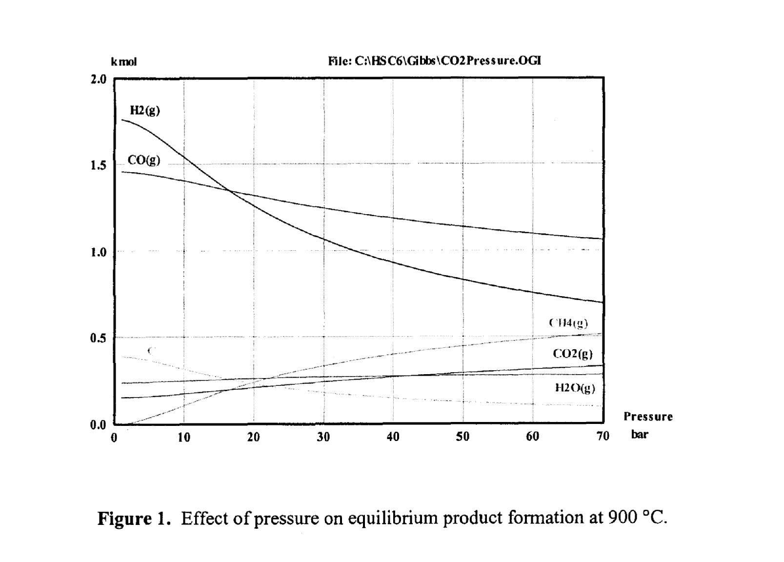

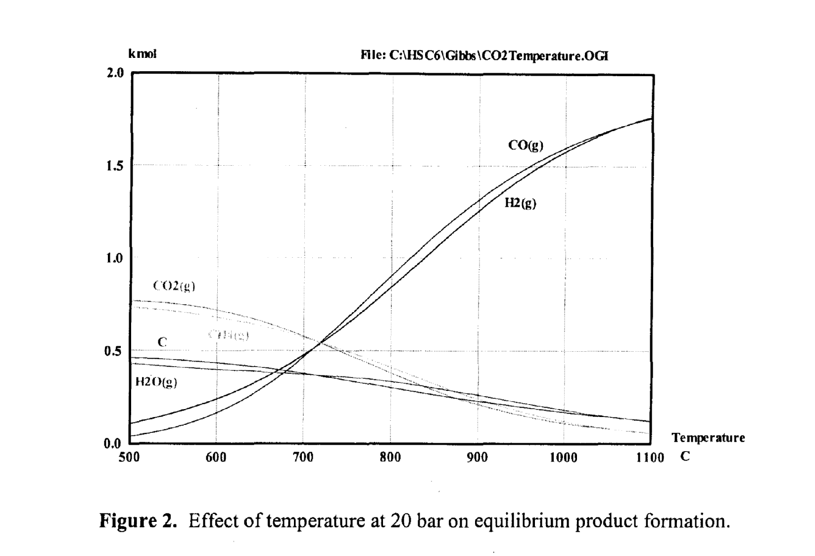
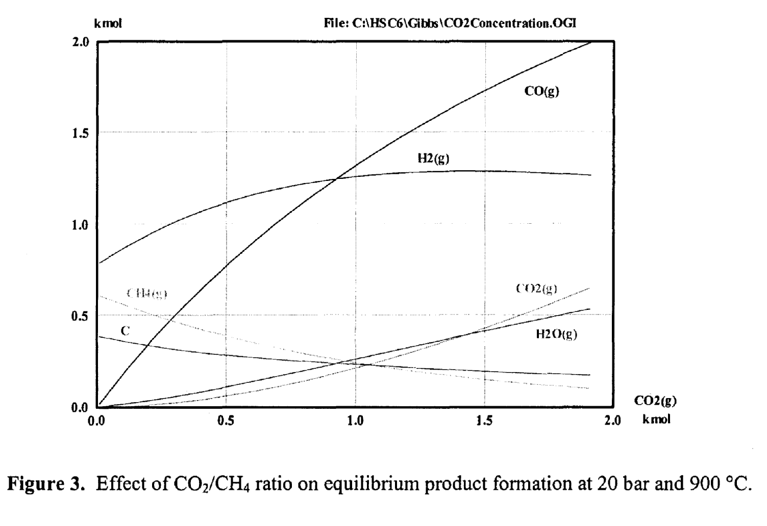

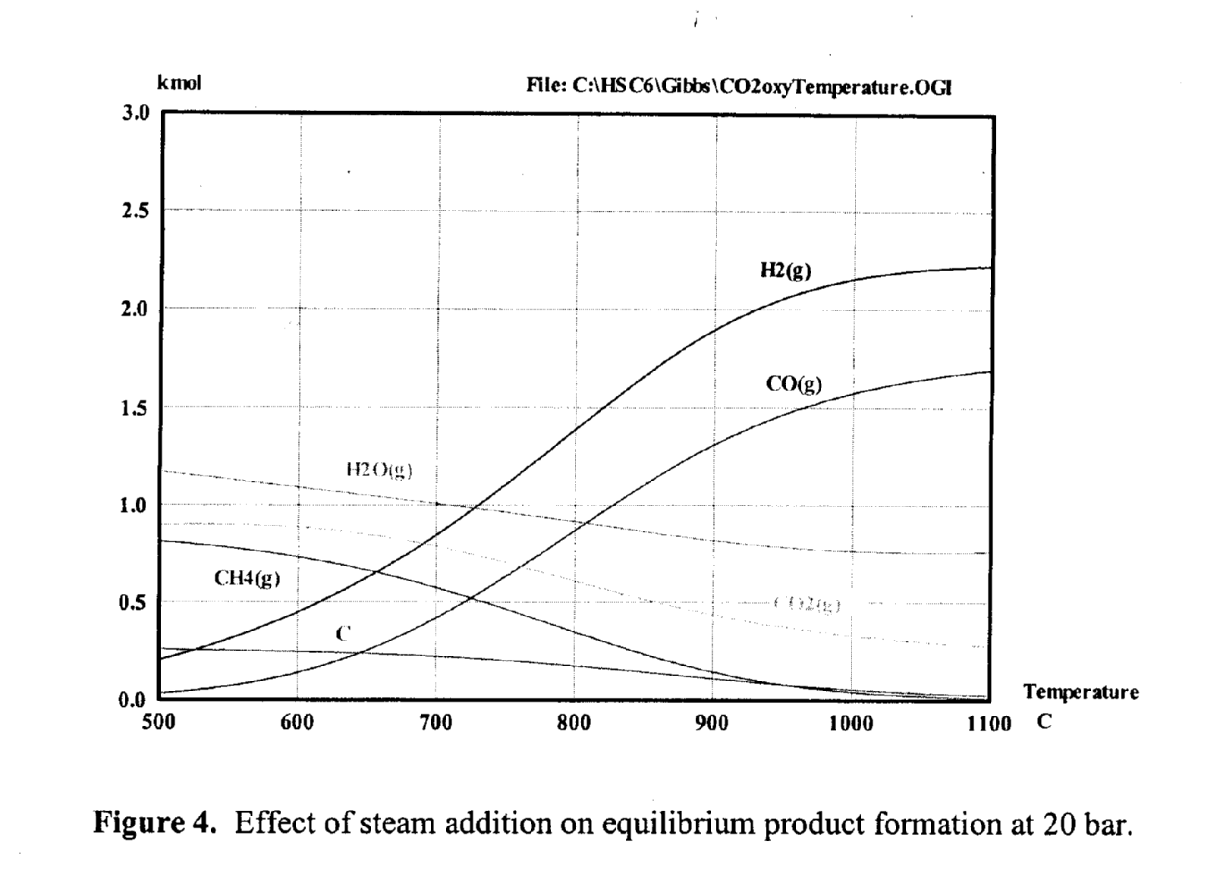

1.D. SCOPE OF THE CHAPTER

While this chapter briefly addresses the catalytic technology associated with carbon dioxide reduction by hydrocarbons, in general, the major emphasis is restricted to the carbon dioxide reduction by methane. The chapter surveys the existing literature and presents first a brief review of kinetics study of carbon dioxide reduction by methane. The available kinetic mechanisms and models are reviewed. Subsequently, the literature on catalysis of carbon dioxide reduction by methane is analyzed. It is clear from the literature that while Ni catalyst has been generally accepted as the one with the most commercial viability, more recent studies have examined noble metal and Ni composite catalysts. Various innovative supports such as hexaaluminate spinel and xengel have also been examined. The composite catalysts as the innovative supports show much promise for future research and commercial developments.

1.E. SCOPE OF THE REVIEW
The major emphasis of the paper is placed on the mechanism, kinetics, and catalysis of dry reforming of methane.
The review first evaluates various kinetic mechanisms and models presented in the literature for the catalytic dry reforming of methane. The assessment of these mechanisms and models is armed towards a) the determination of rate limiting steps b) the factors affecting coke deposition which limits the time for catalyst activity and stability c) the factors affecting catalyst activity and the ignition temperature for the reforming d) the factors that give high conversions of CO₂ and CH₄ and more selectivity for CO and H₂ and finally e) the factors that make the entire process more energy efficient.
Since dry reforming is a catalytic process, the above mentioned factors lead to the optimum design of the required catalyst. Towards that end, in the past Ni catalyst was considered to be most commercially viable because of the hit activity, (i.e. better turnover rate), good stability, and cost. The paper evaluation recent developments in other noble and transitional metals, such as Rh, Ru, Pt I XXX etc., bi- and tri- metallic catalysts, and Ni-componte catalysts. The paper also examines different support systems and promotes and their interactions with metals and their roles in overall catalyst activity and stability. A comparative performance of dray and steam reforming of methane and their interdependence is XXX didn’t know word briefly examined.
In recent years, some progress on the dry reforming of higher hydrocarbons and alcohols has been made. The paper critically analyses this progress.
Finally, based on this review, the paper outlines some concluding remarks on the level of the progress and recommends some directions for the future research.

The chapter also shows that while the carbon dioxide reductions by lower hydrocarbons (C₂-C₇) are more complex, they need to be further investigated to improve commercial applications of the basic concept. The application for upgrading of FT-off gases has been recommended. The future research for carbon dioxide reduction by hydrocarbon under supercritical conditions and other commercially viable approaching for carbon dioxide transformation are briefly assessed.
2. KINETICS OF CARBON DIOXIDE REDUCTION BY HYDROCARBONS

The equilibrium CO₂ reduction by CH₄ is generally expressed as:
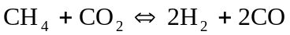 (38)
This reaction is generally influenced by the reverse water-gas shift reaction:
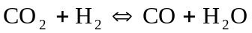 (39)
These two reactions together result in H₂/CO ratios that are less than unity. Rostrup-Nielsen and Hansen (78) have shown that the water-gas shift reaction is extremely rapid under typical methane reforming conditions. Majority of the literature reports that RWGS reaction operates very close to thermodynamic equilibrium during CH₄-CO₂ reforming.

While CO₂ reduction by CH₄ has been extensively studied, only four kinetic models for this reaction has been proposed in the literature. These are described in Table 4. The turnover frequencies for CO on Ni catalysts for various supports are illustrated in Figure 5. It is clear from this figure that the best support was TiO₂ followed by C, SiO₂, and MgO in that order. The activation energies for various types of Ni catalysts are shown in Table 5. H₂/CO ratio as function of CO₂ conversion for various Ni catalysts is shown in Figure 6. Once again TiO₂ gives more favorable H₂/CO ratio than MgO support.
Table 4 (79).
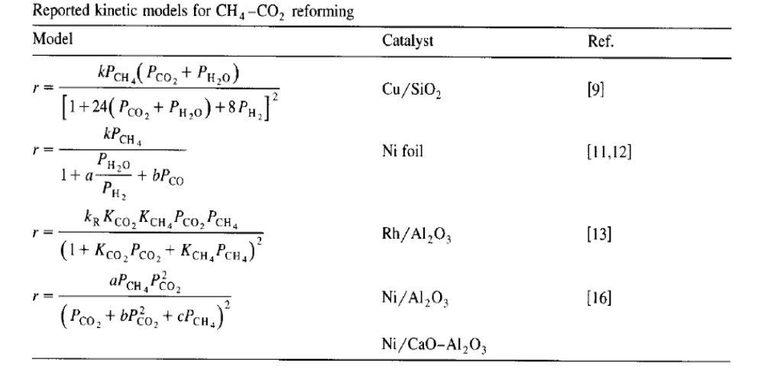

Table 5 (79).
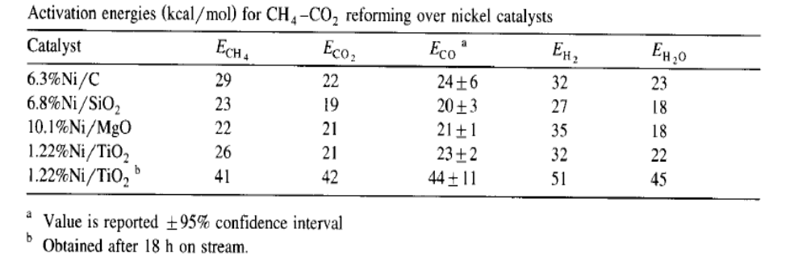

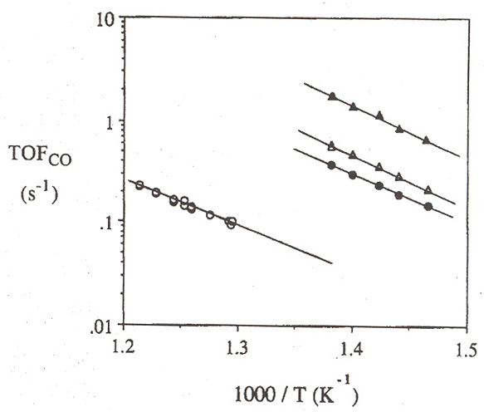
Figure 5. Turnover frequencies for (▲) Ni/TiO₂, (Δ) Ni/C, (●) Ni/SiO₂, and (○) Ni/MgO, calculated from rates of carbon monoxide formation and irreversible carbon monoxide uptakes on the fresh catalyst samples. Reaction conditions: CH₄/CO₂/He = 1/1/1.8, P ≈ 740 Torr (79).

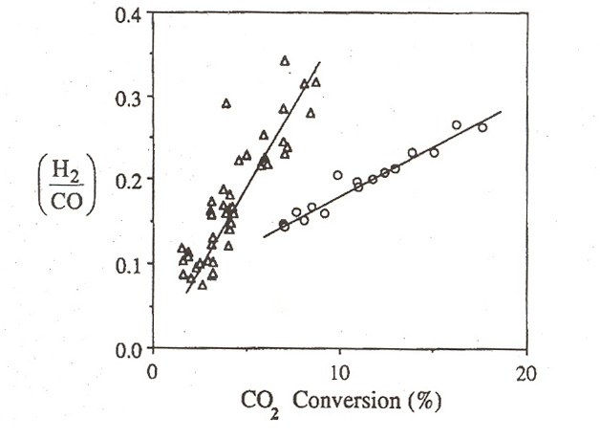
Figure 6. The hydrogen to carbon monoxide product ratio plotted as a function of carbon dioxide conversion for (Δ) Ni/TiO₂ and (○) Ni/MgO. Reaction conditions: CH₄/CO₂/He = 1/1/1.8, P ≈ 740 Torr (79).
Bradford and Vannice (79) examined the dependence of the rates of H₂ and CO formation and CH₄ and CO₂ consumptions on the feed partial pressure of CH₄ and CO₂ over a broad range of temperature and Ni/TiO₂, Ni/C, Ni/SiO₂, Ni/MgO catalysts. The reaction orders for CH₄, a and CO₂, b, were determined from a power law fit to the experimental data of the from
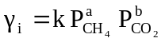 (40)
Various values of a and b obtained from this study are described in Table 6.
Bradford and Vannice (79) also presented a generalized reaction sequence for CO₂ reduction by CH₄ as (79,80) :
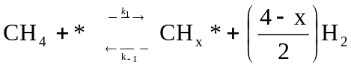 (41)
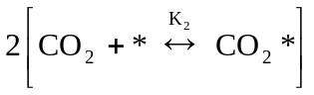 (42)
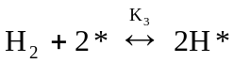 (43)
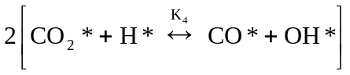 (44)
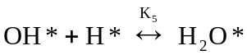 (45)
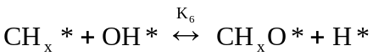 (46)
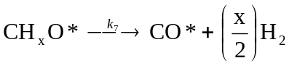 (47)
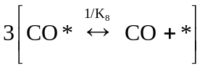 (48)
which corresponds to the overall reaction stoichiometry
Table 6. Power rate law reaction orders for nickel catalysts (79).
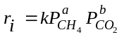
 | Ni/MgO |  |  |  |  |  | Ni/TiO₂ |  |  |  |  |  | Ni/SiO₂ |  | Ni/C
 | a |  |  | b |  |  | a |  |  | b |  |  | A | b | a | b
i | 773 K | 798 K | 823 K | 773 K | 798 K | 823 K | 673 K | 698 K | 723 K | 673 K | 698 K | 723 K | 723 K | 723 K | 723 K | 723 K
CO | 0.64±0.02 | 0.61 | 0.57 | 0.15±0.01 | 0.19 | 0.21 | 0.67 | 0.55 | 0.44 | 0.10 | 0.25 | 0.30 | 0.18 | 0.44 | 0.33 | 0.43
CO₂ | 0.60±0.02 | 0.58 | 0.52 | 0.27±0.01 | 0.33 | 0.36 | 0.86 | 0.75 | 0.43 | -0.22 | 0.28 | 0.41 | 0.27 | 0.64 | 0.45 | 0.54
CH₄ | 0.72±0.01 | 0.63 | 0.61 | 0.01±0.03 | 0.04 | 0.05 | 0.13 | 0.25 | 0.40 | 1.55 | 0.30 | 0.18 | 0.44 | 0.15 | 0.72 | 0.77
H₂ | 1.22±0.18 | 1.18 | 1.16 | -0.54±0.06 | -0.43 | -0.36 | 1.76 | 1.32 | 0.90 | -0.61 | -0.53 | -0.15 | 0.49 | 0.11 | 1.03 | -0.05

Table 7. Forward CH₄ reaction rates, rate constants, preexponential factors, activation energies, and kinetic isotopic effect (KIE) for CH₄ reactions on 7 wt% Ni/MgO-A (873 K, 20 kPa CH₄, 25 kPa CO₂ or H₂O, 100 kPa total pressure, balance Ar) (79).

 |  |  |  | Preexponential factors (s⁻¹ kPa⁻¹)
Coreactant | Turnover rate (s⁻¹) | Rate constant (s⁻¹ kPa⁻¹) | Activation energy (kJ/mol) | Measured | Estimated^{b} | KIE
CO₂ | 4.0 | 0.20 | 105 | 3.8 x 10⁵ | 5.5 x 10³ | 1.62
H₂O | 4.1 | 0.20 | 102 | 2.5 x 10⁵ | 5.5 x 10³ | 1.66
None | 3.8ª | 0.19 | 99 | 1.6 x 10⁵ | 5.5 x 10³ | 1.71
ª Initial CH₄ turnover rate on Ni surface.
^{b} Calculated based on transition-state theory treatments of CH₄ activation steps proceeding via an immobile activated complex.

(49)

Bradford and Vannice experimentally verified the reaction mechanism proposed above.
The proposed kinetic model fit the experimental data well for various catalysts, temperatures,
and partial pressures of CO₂ and CH₄ as shown in Figures 7a and 7b.
The main conclusions regarding the kinetic mechanism for CO₂-CH₄ reaction over Ni catalysts are (a) CH₄ decomposition and CH_{x}O decomposition are slow kinetic steps, (b) CO₂ participates in the reaction mechanism through the reverse water-gas shift to produce surface OH groups and (c) surface OH groups react with adsorbed CH_{x} intermediates to yield a formate-type intermediate, CH_{x}O, which decomposes to yield H₂ and CO. Two main energetic roles of catalysts are to reduce activation barriers for CH₄ dissociation and CH_{x}O decomposition. The support may serve as a sink for surface hydroxyl groups, such that the active site for CH_{x}O formation and subsequent decomposition may be at the metal-support interface. The proposed CH₄-CO₂ reforming should be applicable to CH₄-H₂O reforming. The catalysts that exhibit suppressed or weak, carbon monoxide adsorption can sufficiently resist excessive carbon formation during CH₄-CO₂ reforming due to the inhibition of carbon monoxide disproportionation. The above described reaction scheme is graphically illustrated in Figure 8.

There are many similarities in basic reaction mechanism and the effectiveness of transition metal catalysts for dry and wet reforming. Wei and Iglesia (81) showed that turnover rates for forward reactions of CH₄/CO₂ and CH₄/H₂O for Ni/MgO catalyst were proportional to CH₄ pressures (5-400 kPa) and independent of partial pressures of CO₂ and H₂O co-reactants (5-450 kPa). These turnover rates and their first-order rate constants and activation energies are also similar to those measured for CH₄ decomposition, indicating that these reactions are mechanistically equivalent and the C-H bond activation is the sole kinetically relevant step in all of
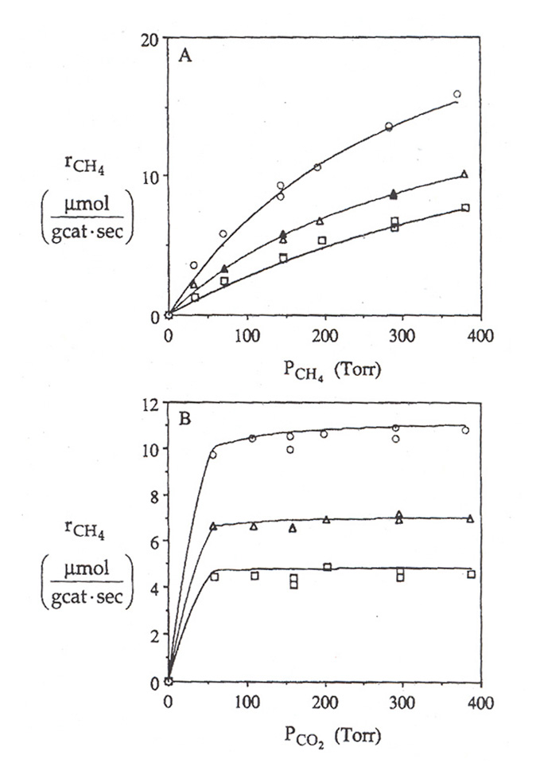
Figure 7a. Fit of the proposed kinetic model for CH₄-CO₂ reforming as a function of (A) methane partial pressure and (B) carbon dioxide partial pressure for Ni/MgO at (□) 773 K, (Δ) 798 K, and (○) 823 K (79).

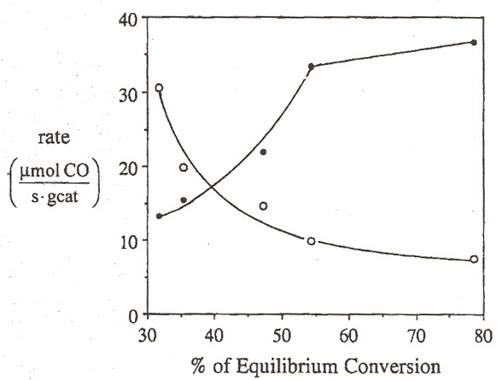
Figure 7b. Measured net rate of carbon monoxide formation (○) and calculated reverse rate of carbon monoxide consumption via methanation (●) as a function of percent equilibrium conversion for Ni/TiO₂ at 723 K. Reaction conditions: CH₄/CO₂/He = 1/1/1.8, P ≈ 740 Torr (79).
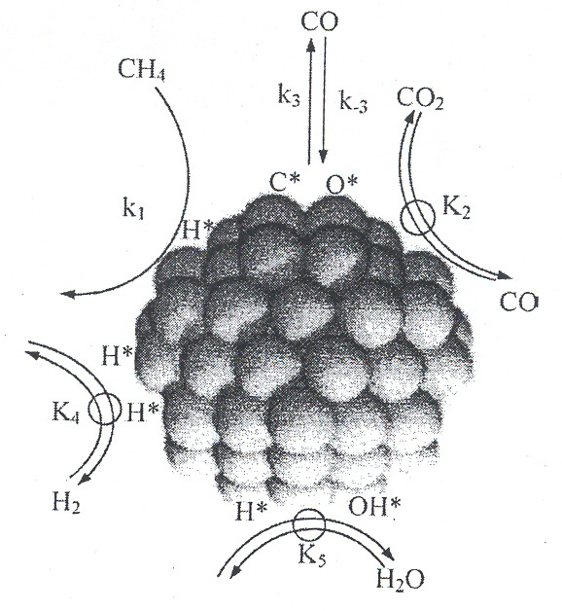
Figure 8. Sequence of elementary steps for CH₄-reforming and water-gas-shift reactions on Ni-based catalysts (→ irreversible step, quasi-equilibrated step, reversible step, k_{i} is the rate coefficient and K_{i} is the equilibrium constant for a given step i) (81).

these reactions. The mechanistic feature of this reaction on Ni surface resembles these for supported noble metal catalysts (Rh, Pt, Tr, Ru). These direct measurements of C-H bond activation turnover rates allow the first direct and rigorous comparison of the reactivity of Ni and noble metal catalysts for CH₄ reforming reactions. Forward CH₄ turnover rates for CO₂ and H₂O reforming of CH₄ on different metal clusters as a function of metal dispersion on various catalyst supports at 600 °C, 20 kPa CH₄ are shown in Figure 9. It is clear from these data that the results are very similar for both dry and wet reforming and the turnover rates depends very strongly on both metals and supports. The effects of H₂ and CO partial pressures on methane turnover rates for dry and wet reforming are shown in Figure 10 for 7 wt%/Ni/MgO-A catalyst at 600 °C, 20 kPa CH₄ and 20 kPa CO₂ or H₂O (with 100 kPa total pressure with balance He). These results once again indicate similarities in dry and wet reforming reactions. The rate constants for forward reaction rates for wet and dry reforming are illustrated in Table 7. These data are also very similar to the CH₄ decomposition reaction. In all cases, CH₄ reaction rates are limited solely by C-H bond activation steps and unaffected by the identity or concentration of co-reactants. Isotropic tracer and exchange studies (81) have shown that C-H bond activation is the only kinetically relevant step and that it is exactly as reversible as the overall reforming reactions. Isotropic evidence also showed that activation of H₂, CO₂, and H₂O was reversible and quasi-equilibrated during CO₂ and H₂O reforming reactions of CH₄.
In CO₂ reduction by hydrocarbons, the importance of activation of CO₂ cannot be underemphasized. Its reduction with oxidation of hydrocarbons and other organic substances is effectively carried out by the Mn-containing catalysts. The obligating condition is the selection of the system which accepts and activates CO₂. The acidic properties of CO₂ require to use catalysts with basic properties. But alkaline and alkaline earth oxides are ineffective because of

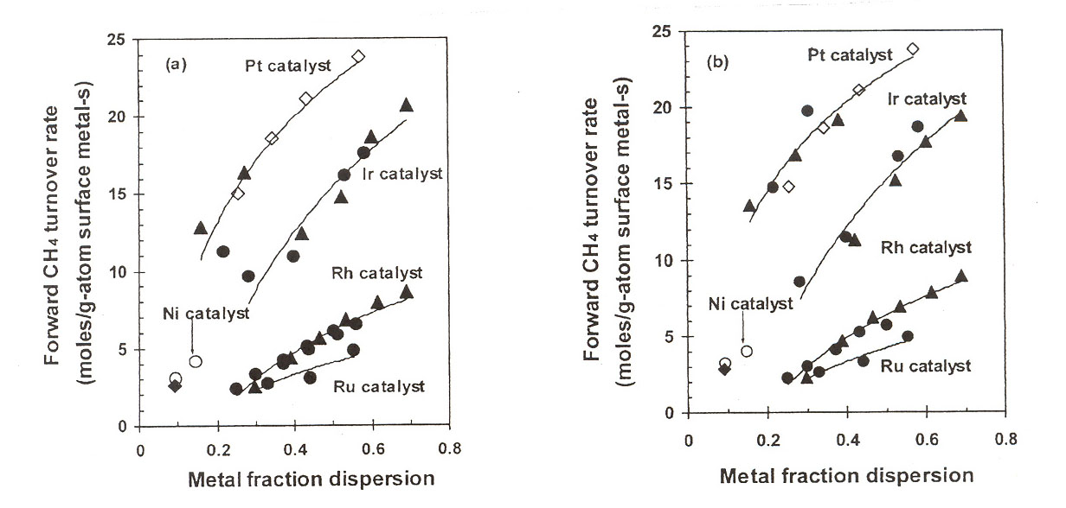
(a) (b)

Figure 9. Forward CH₄ turnover rates for CO₂ (a) and H₂O (b) reforming of CH₄ on different metal clusters as a function of metal dispersion on various supports (873 K, 20 kPa CH₄, (▲) ZrO₂, (●) γ-Al₂O₃, (◊) ZrO₂-CeO₂ as support, (○) MgO-A, (♦) MgO-B) (81).

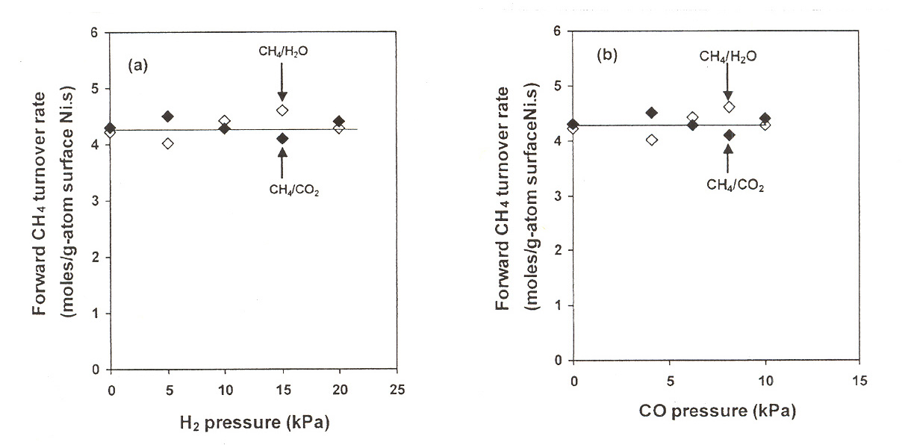
(a) (b)

Figure 10. Effect of H₂ (a) and CO (b) partial pressures on forward CH₄ reaction rate for CH₄-reforming reactions on 7 wt% Ni/MgO-A (873 K, 20 kPa CH₄, 20 kPa CO₂ or H₂O, 100 kPa total pressure, balance He) (81).

Table 8 (82)
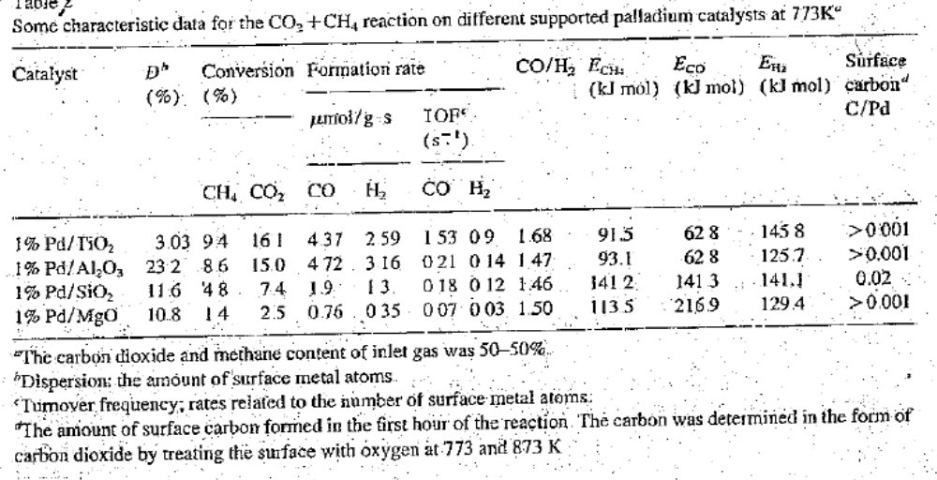
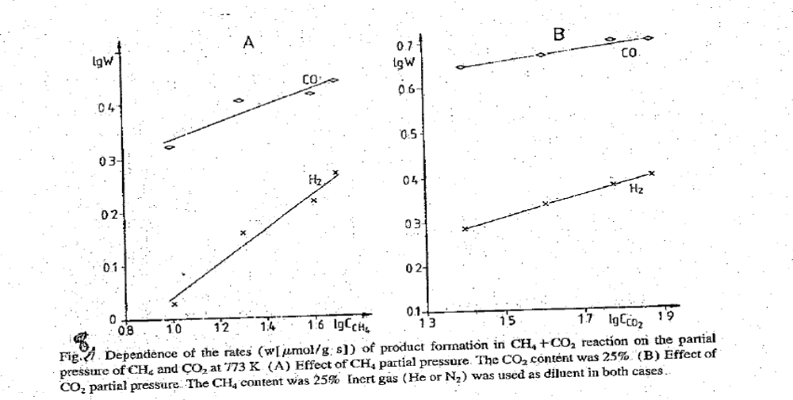
Dependence of the rates (w[umol/g s]) of product formation in CH₄ + CO₂ reaction on the partial pressure of CH₄ and CO₂ at 773 K (A) Effect of CH₄ partial pressure. CO₂ content was 25% (B) Effect of CO., partial pressure The CH₄ content was 25% Inert gas (He or N₂) was used as diluent in both cases.

Figure 11 (82).

strong carbonate formation. Oxides of a moderate basicity are necessary and, moreover, their carbonates must be decomposed with CO₂ reduction, Mn satisfies these requirements:
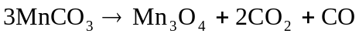 (50)
A modification of Mn-containing catalyst by other oxide (for example, Cr, Ca, K) influences both its accepting properties and degree of surface reaction.
On Pd catalyst, the dissociation of CO₂ and CH₄ and the reactivity of the surface carbon formed have been examined. The dissociation of CO₂ occurred at the lowest temperature 373 K (100 °C) on Pd/TiO₂. It was greatly promoted by the presence of CH₄. The decomposition of methane at the temperature of the CH₄ + CO₂ reaction (i.e., 500 °C) proceeds initially at a high rate yielding hydrogen and small amounts of ethane and ethene. The deposition of surface carbon was also observed, which was hydrogenated only above 720 °K. The reaction between CO₂ and CH₄ occurred rapidly above 673 K to give CO and H₂ with a ratio of 1.3-1.7. Very little carbon was deposited during the reaction of a stoichiometric gas mixture. Some characteristic data for the CO₂ + CH₄ reaction on different supported Pd catalysts at 773 K are described in Table 8. The effects of partial pressures of CH₄ and CO₂ on the rate of product formation in CH₄ + CO₂ reaction is shown in Figure 11.

Finally, the study of Topalides et al. (18) showed that methane conversion during dry reforming can be expressed by the rate expression:
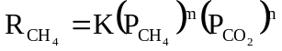 with m = 1 and n = 0 (51)
These results were explained using L-H kinetics and admitting that the reactants adsorbed on distinct and discreet active site of solids, namely the methane is weakly bound on the metallic and the CO₂ strongly adsorbed on the oxidic phase of the catalyst. The rate of CO₂ conversion was considered to be sum of rate of CO₂ conversion was considered to be sum of rate of methane conversion plus the rate of the reverse water-gas shift reaction. The dependence of revenue water-gas shift reaction on CO₂ partial premix is similar to that for CH₄ conversion. On the other hand, rate of reverse water-gas shift conversion on the partial pressure of H₂ shows a maximum which might be due to strong inhibition by the products CO and H₂O interacting and adsorbed strongly on that active surface.

3. CATALYSIS FOR CO₂ REDUCTION BY HYDROCARBONS
3.A. NICKLE CATALYSTS:
The most commonly used catalyst for CO₂ reduction is by hydrocarbon is Ni catalyst.
Various forms of Al₂O₃ as support for Ni has been widely used. Guo et al. (13) found that the deep dehydrogenation of CH₄ was inhibited on Ni catalysts when MgAl₂O₄ replaced the catalyst support Y-Al₂O₃. Three carbon species (i.e., C_{α}, C_{p}, and C_{y}) were formed on the catalyst surface during CH₄ decomposition. C_{y} was graphite-like carbon species, which was unexpectedly more active toward CO₂ than H₂ and O₂. The unique reactivity of CO₂ with different coke species was ascribed to the carbonate, bidentate and formate species formation on MgAl₂O₄ surface. These surface species enhanced the oxidation of surface carbon species and hence the high stability of Ni/MgAl₂O₄ catalyst in dry reforming of methane.
Cui et al. (21) studied dry reforming over Ni/α-Al₂O₃ catalyst in details. The activation energies of CH₄ dissociation and CO₂ conversion, together with the reaction orders of CH₄, CO₂, H₂, and CO showed that the reaction mechanism can be divided into three regions: 550-575 °C, 575-650 °C, and 650-750 °C. The reaction was constant in the low- and high-temperature regions but varied with temperature in the middle region. The dissociation of CH₄ into CH_{x} species and hydrogen species on the Ni active sites reached equilibrium state above 650 °C. The surface oxygen species originating from CO₂ dissociation became removable and they moved to Ni active sites to react with CH_{x} species above 575 °C. The reaction rate of CH₄ into CO₂ was lower than that of CH₄ dissociation above 650 °C, leading to durative carbon deposition on the Ni/α-Al₂O₃ catalyst throughout the dry reforming. CO competed with CH₄ on Ni active sites and inhibited dry reforming below 650 °C, and CO was rapidly described above 650 °C. The formation of hydrogen was a rapid step due to equilibrium with Ni-H in the reforming reaction. Therefore, CH₄ dissociation was the rate limiting step and CO desorption also restrained the dry reforming in 550-575 °C. The reaction between CH_{x} and CO₂ became rate limiting step in 650-750 °C and the restraining steps were switched from the former two steps to the latter one in 575-650 °C. The reaction temperature alters the reaction steps, including the amount of Ni-H on catalyst, the removability of the oxygen species, and the desorption of CO from catalysts.
A number of other support systems for Ni has also been investigated in the literature. Rezaei et al. (45) examined mesoporous noncrystalline zirconia powders (ZrO₂-3% M₂O_{x}; M:Ce, La and K) with high surface area and pure tetragonal crystallite phase prepared by the surfactant-assisted routes. This support for Ni found to have good potential for Ni catalysts.
Nagavasu et al. (29) showed that the dry reforming of CH₄ over Ni catalysts is accompanied by gasification of carbon species with CO₂ and water-gas shift reaction. The latter caused wet reforming to occur simultaneously. The initial rate of carbon formation decreased with higher partial pressure of carbon dioxide, but the reaction continued for a longer period in the presence of CO₂ because carbon species remaining of the Ni surface were gasified by carbon dioxide. Low partial pressure of CO₂ yield higher carbon. For dry reforming, this study showed that the reaction gas composition is near the equilibrium and has a low driving force for carbon formation.
Olafsen et al. (32) compared dry reforming of methane and propane over Ni/SiO₂ and Ni/Mg(Al)O hydrostalcite-derived catalyst. They noted major differences in these two reforming reactions. Higher stability of the hydrostalcite-based system was assigned to (a) to the morphology and structure of Ni phase remaining in strong interaction with the support under reaction conditions, while Ni particles are easily extracted from silica surface and (b) to an active role of the hydrostalcite support which is to provide continuously oxygen to the nickel surface. The methane reforming generates less surface and out -of-surface carbon than propane reforming. This might be related to the competition between the initial steps of cracking, polymerization, and carbon oxidation which are highly sensitive to the nature and structure of molecules to be reformed (84).
Numerous other supports for Ni catalysts have been also examined in the literature. Under specific stoichiometric compositions of alumina-aluminum phosphate material can produce large pore and high surface area catalyst supports. Nickel impregnation on such a catalyst resulted in substantial loss of pore size. However, Ni catalysts prepared by co-precipitation retained adequate average pore sizes. Catalysts where Ni is co-precipitated with the support pre-cursors have been compared with impregnated Ni catalysts. Both Ni/g-Al₂O₃ and Ni/AAP catalysts deactivated rapidly but co-precipitated nickel with AAP catalysts were stable. The stability of the co-precipitated catalyst is thought to be the results of fine and more dispersed nickel particles and the formation of strong metal-support interactions such as the NiAl₂O₃ spinel. The spinel phase engages nickel particles in strong metal-support interactions and prevents nickel particles from sintering. However, the same strong metal-support interactions reduce the amount of Ni surface and thus the degree of reduction at 650 °C. Therefore, overall catalytic activity is lower than with the impregnated catalysts at identical conditions. Lower activity in co-precipitated catalysts was compensated by higher Ni loading and increased operating temperatures. The optional Ni loading was found to be between 15-20 wt%. Temperature could be increased up to 800 °C without loosing activity.
Another successful support system for Ni catalyst examined in the literature is Ni(x)/CaHAp and Ni(x)/CaFAp. These Ni-loaded hydroxyapatite and fluroapatite gave Ni existence in three forms (a) large crystallites of NiO deported on the surface of catalysts, (b) NiO in small particles exhibiting strong interaction with the support, and (c) a phase where Ni is partially exchanged with calcium ions in the structure of phosphate. Moreover, the distribution of the loaded Ni between these different forms depends on the nature of the carrier. CO₂ reforming of methane over Ni(x)/CaHAp and Ni(x)/CaFAp at 600 °C showed that the conversion at all temperatures are managed by the thermodynamic equilibrium and H₂/CO ratio lower than 1.
While various supports for Ni catalyst have been examined, one support that stands out is the partial substitution of La³⁺ for Sr²⁺ in La_{1-x}Sr_{x}NiO₃. This structure decreases the oxidation state of Ni favoring its reduction and producing solids with the spinel type structure, due to the increase on vacancies that facilitate the mobility of oxygen toward the surface of solid. The redox processes on the pervoskite structure occurs through intermediary species and they are not reversible, since changes of phases occur forming first La₂Ni₂O₃ at 420 °C, NiO at 610 °C and Ni, La₂O₃ at 690 °C. While La_{0.6}Sr_{0.4}NiO₃ becomes NiO at 500 °C and when the temperature increases 700 °C, it is reduced completely to Ni, La₂O₃, and SrO. Before the reaction, an important adsorption of CO₂ occurs, contributing to the formation of La₂O₂CO₃. The high activity of thin precursory solids present in the dry reforming of methane is due to the presence of Ni⁰ during the course of the reaction and to the formation of La₂O₂CO₃ that allows the oxidation of methane and the regeneration of La₂O₃, besides suppressing carbon deposits.
The above-described pervoskite-type oxides of the general formula ABO_{x} (A: lanthanide, B: transition element) show particular promise for applications involving high temperatures, owing to their high stability. These structures offer the possibility of varying the dimensions of unit cell by substitution of the A ion, and thereby co-valence of the B-O bond in ABO₃ structure. Moreover, partial substitution of A and B sites can strongly affect catalytic activity due to stabilization of unusual oxidation states of the B component and to simultaneous formation of structural defects, which are responsible not only for part of the catalytic activity, but also oxygen mobility with the crystal lattice, due to non-stoichiometry created by substituting the A site. Many works have been carried out, like one mentioned above, in order to increase activity of partial substitution of the A cation by cations of different valence-like Ce⁴⁺ and Sr²⁺.

The reduction of CH₄ by CO₂ has been investigated using Ni-based perovskites because these systems are characterized by significant resistance of coking La_{1-x}Sr_{x}NiO₃ (x = 0.0 – 0.1) and La_{2-x}Sr_{x}NiO₄ (x = 0.0 – 1.0) perovskites series displayed different performances in the dry reforming of CH₄. LaNiO₃ shows high activity without coke formation while La₂NiO₄ is inactive among Sr-substituted pervoskites, La_{0.9}Sr_{0.1}NiO₃ and La_{0.8}Sr_{0.2}NiO₄ and display the highest activity with coke formation on the surface. Initially the catalyst activity increases with time and then reaches steady state. Such an increase in catalyst performance is associated with the transformation of original pervoskites into La₂O₂CO₃ and SrCO₃ with highly dispersed Ni metal particles due to the H₂ generated in the reaction. It has also been suggested that the interactions between Ni and La species creates a new type of synergistic active sites at the Ni-La₂O₃ interface, which offer active and stable performance of CO₂ reforming of methane to syngas. De Lima et al. (35) showed that partial replacement of Ce by La caused an increase in catalyst activity and inhibition of coke formation on the catalyst surface. Furthermore, only at low Ce contents is the insertion of the Ce in pervoskite structure possible due to its low solubility leading to increased catalyst activity and inhibition of carbon formation.

As mentioned above, the spinel structure helps the performance of Ni catalysts. Sahli et al. (38) studied NiAl₂O₄ spinel for dry reforming using sol-gel method with propionic acid. This study indicated that if Ni/Al is higher than 0.5, free NiO is present on spinel and favors the reduction of Ni at low temperature. Stoichiometric spinel seems difficult to obtain as pure phase and forms easily small zones of free nickel oxides. If Ni/Al ratio is lower than 0.5, a solid solution of Al₂O₃ and NiAl₂O₄ is formed and high surface area is obtained. In order to get good performance of the reforming of methane into synthetic gas with limited coke formation, small metallic particles must be obtained. The growth of Ni particles needs to be limited. The sub-stoichiometric spinel structures present the properties to be an active catalyst: stability of structure at low temperature, high dispersion of NiO into the spinel, formation of Ni phase in the same temperature area than the catalytic reaction and presence of Ni oxide to limit the growth of the particles probably by formation of interaction between nickel metal out of structure and Ni oxide of the structure. The formation of carbon is less important with the Al-S spinel.

3.B. NOBLE METAL CATALYST
3.B.1. PD CATALYST
Methane decomposes on supported Pd at 500 °C to give hydrogen, a small amount of ethane and a carbonaceous residue. On Pd/SiO₂, the formation of ethylene has also been observed. The carbon formed in the high-temperature decomposition of methane is rather unreactive and hydrogenated above 720 K. The dissociation of CO₂ occurred at elevated temperatures on all Pd catalysts to give adsorbed carbon monoxide of different coordinations. A significant support effect has also been observed. The addition of CH₄ to CO₂ promoted the dissociation process. Supported Pd is an active catalyst in the high-temperature reaction of CO₂ + CH₄ to produce H₂ and CO with no or only very little carbon deposition. The order of activity of the catalysts, based on turnover frequencies is Pd/TiO₂ > Pd/Al₂O₃ > Pd/SiO₂ > Pd/MgO
3.B.2 PT CATALYSTS
A number of studies (56) have been reported for CO₂ reduction by methane over Pt catalysts with a variety of supports such as g-Al₂0₃, A1₂0₃, Zr0₂, and SrTiO₃. Barrai et al. (6) showed that for Pt-gAl₂O₃ catalyst, more carbon was deposited at higher temperatures (900 °C) than at lower temperatures (500-700 °C). However, the catalyst was more active at higher temperatures. The explanation for this could be that while carbon deposition is favored under these conditions, only at higher temperatures, there is enough energy to initiate boudard reaction with CO₂ in the reactant stream serves to gasify carbon on the surface to CO. O’Connor et al. (31) examined two different supports for Pt catalysts. The main difference between the two catalysts was the carbon dioxide dissociation. For A1₂0₃, this step is assisted by hydrogen. Over Zr0₂ support, this step takes place involving surface vacancies. Also, large pools of formate and carbonate species are present on zirconia. Both Al₂0₃ and Zr0₂ have large storage capacities for hydrogen that is probably retained on the catalyst support in the hydroxyl groups. This study also showed that all the carbon deposited on the catalyst mostly came from CH₄ and very little from CO₂ (less than 1%). With Zr0₂, the carbon formed was very active towards hydrogenation and was, therefore, a reaction intermediate. However, for A1₂0₃, a second less active carbon species was formed and this species was thought to lead to the deactivation of the catalysts.

Just as Ni catalysts, Topalides et al. (18) also studied Pt supported on a perovskite solid
S_{r}T_{i}O₃. This solid can be considered as the fast member of the substituted series Pt/Sr_{1-x} and
La_{x}Ti_{3±X}. The choice of perovskite as support stems from the fact that in the past noble metal
supported on mixed valence oxidic solids have shown superior catalytic activity for reactions like the lean de-NO_{x} and NO + CH₄ + O₂ conversion.

3.B.3 RENIUM CATALYSTS
Claridge et al. (85) studied the effectiveness of rhenium-supported on y-alumina for CO₂ reduction by methane. They showed that this catalyst can achieve thermodynamic equilibrium and give greater than 85% methane conversion at 1050 K (777 °C). No carbon deposition was detected after 72 hrs. The specific activities were comparable to those reported in the literature for ruthenium, rhodium, and iridium. However, the activity of rhenium catalyst decreases dramatically at lower temperatures. Thus, at 873 K (600 °C), the rhenium catalyst gave less than 5% methane conversion which is significantly lower than for other metals. This dramatic temperature effect on the catalyst activity can be attributed to the oxidation of the catalyst. A comparison of dry reforming rates for different metal catalyst and temperature for CO₂/CH₄ = 1.0 is illustrated in Figure 12. At 993 K, the order of specific activity for metals from Figure 12 is Ru > Rh > Ir > Re. At 1050 K, no detectable carbon deposition occurs with rhenium catalysts. The relative rate of carbon deposition was found to be Ni > Pd > Ru > Ir > Re.
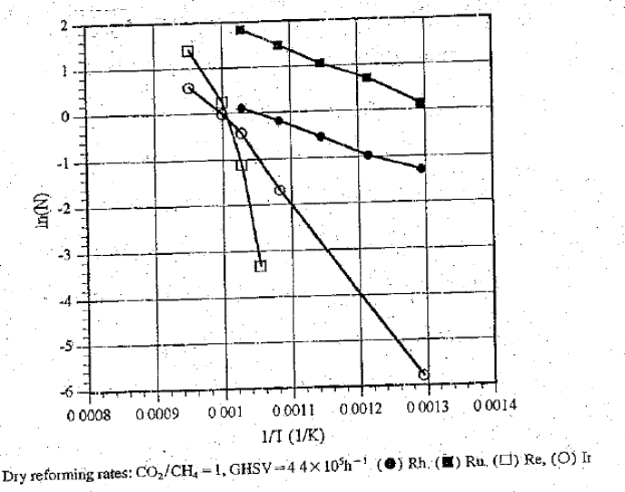
Figure 12 (85).

Figure 12 (85).

3.B.4 RU CATALYSTS
All catalysts show smaller equilibrium constants for methane decomposition than that based on graphite (see Figure 13), the effect being the largest for the noble metals. Ru and Rh show high selectivity for carbon-free operation, which can be ascribed to high rates for CO₂ reduction by methane combining with low carbon formation rates. Similar high selectivity can be achieved with sulfur-passivated nickel catalyst. The rates of carbon formation in the 95/5 mol/mol methane/hydrogen mixture are shown in Figure 14. Ni shows much higher carbon formation rates than the other metals. The differences being most significant at 500 °C. Ru has a low rate of carbon formation at 500 °C and 650 °C as well.

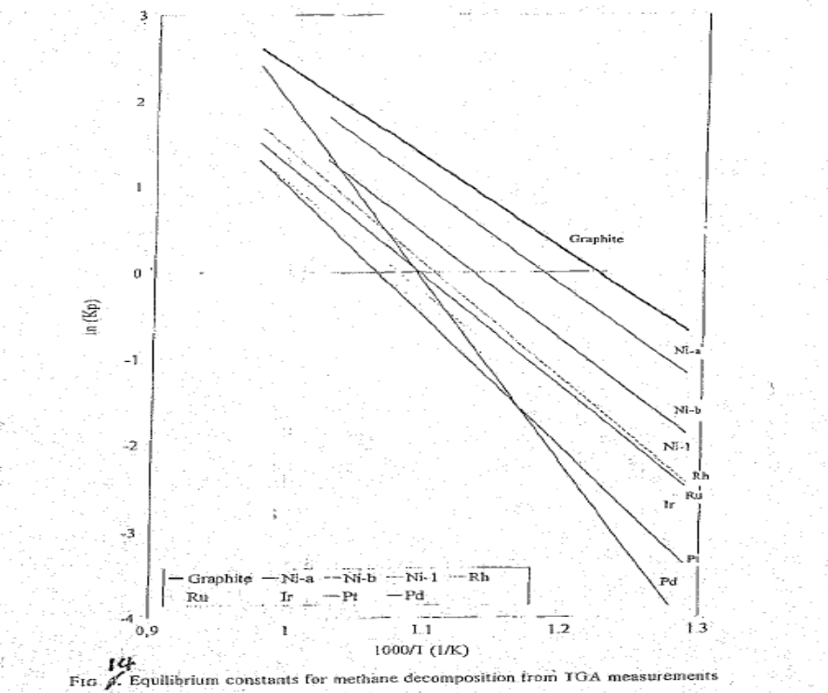
Fig 13. Equilibrium constants for methane decomposition from TGA measurements
Figure 13 (78).

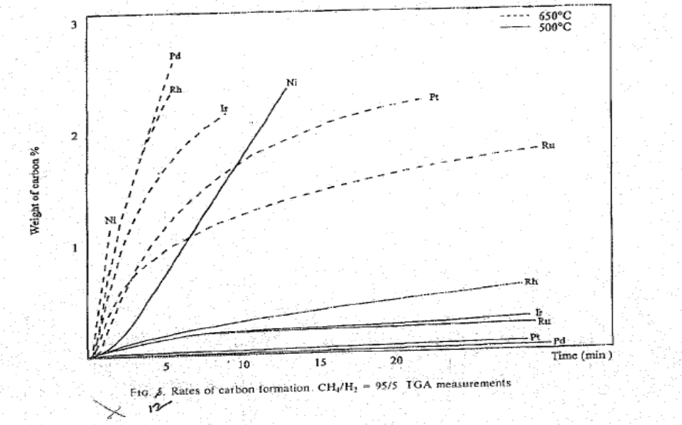
FIG. 14. Rates of carbon formation. CH₄/H₂ = 95/5 TGA measurements
Figure 14 (78).

Ru might be considered as a candidate for CO₂ reduction by methane, being preferred in view of its lower price compared to rhodium (by a factor of 50-110). However, the availability of Ru (annual production 4 tons/yr) is too low to have a major commercial impact on the total reforming catalyst. The reforming rates (steam and CO₂) of Ru are compared with commercial Ni catalysts in Figure 15. Equilibrium constants for methane decomposition from TGA measurements are shown in Figure 14. These data show that Ni still has the most favorable equilibrium constants compared to the other metals. Faroldi et al. (47) showed that a low amount of Ru on La₂O₃ (Ru_{(0.6)}/La₂O₃) was very effective and compared well with the best Rh formulation. This may be due to the interplay of Ru oxidation states, varying H₂ partial pressure and optimal Ru concentration with the slight deactivation observed when Ru_{(1.2)} formulation was used in the membrane reactor. A higher amount of graphitic carbon was detected in Ru_{(1.2)} solids in agreement with the decrease in methane conversion.

3.B.5 Rh CATALYSTS
Rh has been the most widely investigated noble metal catalyst for steam and dry reforming. The metal supported on a variety of supports such as Al₂O₃, yttria-stabilized zirconia (YSZ), TiO₂, SiO₂, α-Al₂O₃, MgO, CeO₂, La₂O₃, Nb₂O₅, Ta₂O₅, ZrO₂, Y₂O₃, CeO₂-ZrO₂, La₂O₂ (27%)-SiO₂. The literature separates out Rh, Ru, and Ir catalysts to be more suitable for dry reforming than Ni, Pt, and Pd since the latter set of catalysts are less active and are more prone to deactivation caused by carbonization.
Nakamura et al. (86) studied Rh on a number of supports in the wide temperature range of 550-1000 °K. The catalyst activity follow the order Rh/Al₂O₃ > Rh/TiO₂ > Rh/SiO₂. The

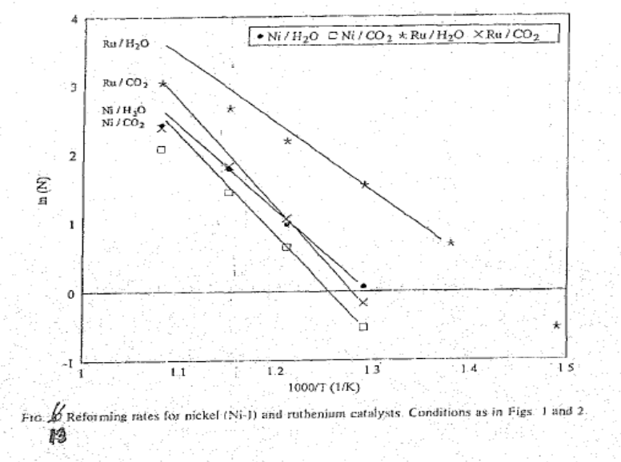
FIG 15. Conditions as in Fig. 14
Figure 15 (78).
catalyst activity of Rh/SiO₂ was promoted markedly by physical mixing of Rh/SiO₂ with metal oxides such as Al₂O₃, TiO₂, and MgO, indicating a synergistic effect. The role of metal oxides and their mixtures may be ascribed to the promotion in dissociation of CO₂ on the surface of Rh.
CO₂ dissociation is considered to be the rate—determining step.

One of the widely investigated supports is Al₂O₃. Olympiou et al. (87) examined Pt, Rh, and Ir on Al₂O₃ support. The large difference in the activity order of alumina-supported Pt, Rh, or Pd metals (Pd < Rh < Pt) seems to correlate with the surface coverage of CO formed on the nobel metal under WGS reaction conditions. WGS reaction with a high H₂O/CO ratio (4:1 v/v) in the 350 - 500 °C range over alumina support passes through a large concentration of OH/H species located on Al support and much smaller concentrations of active adsorbed CO (on the nobel metal) and formate (on the alumina support) species.
Efstathiou et al. (88) showed that reaction steps of the CH₄ reaction pathway over Rh/Al₂O₃ to form CO are faster than those of the CO₂ molecular reaction pathway. The surface coverage of active oxygen species which lead to the formation of CO during the reforming reaction over the Rh/Al₂O₃ catalyst at 650 °C is found to be very small (less than 2%). However, there is a large pool of lattice oxygen species of the yttria-stabilized zirconia (YSZ) support which participate in the formation of CO during the reforming reaction at 650 °C over the Rh/YSZ catalyst. Tracer studies indicate that part of this lattice oxygen may migrate onto the Rh surface to form CO while a large part of it exchanges with gaseous CO₂ followed by dissociation to CO and atomic oxygen on Rh surface. Such lattice oxygen species might be considered responsible for the higher TOF values obtained over the Rh/YSZ as compared to Rh/Al₂O₃ catalyst.

Yakota et al. (28) showed that sulfur impurities 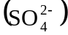 seriously affects the activity of Rh/Al₂O₃ catalyst. The removal of sulfate ions in alumina through calcination in air or reduction with H₂ was one effective way to promote high activity. The impurity inhibits the reduction of RhCl₃ to give Rh which is active for CH₄-CO₂ reaction.
Yin et al. (12) presented a model for dry reforming over Rh/Al₂O₃ catalyst in a circulating fluidized bed. This model can be applied to other catalysts as well. Puolakka et al. (50) showed that dry reforming of n-heptane is attractive way to use CO₂, but will require high temperatures for the optimum production of synthesis gas. Combining CO₂ reforming with partial oxidation provides a solution as the energy requirement decreases. In addition, it reduces the catalyst deactivation by coke formation. They also found that Rh/ZrO₂ catalyst was almost as active as commercial Ni catalyst. Platinum as a oxidizing catalyst was not suitable for the combined CO₂ reforming and PO_{x} reaction, in which the aim is to maximize the carbon dioxide conversion. Typical data showing n-heptane total and cracking conversion and the CO₂ conversion in the combined CO₂ and PO_{x} reaction of n-heptane with various catalyst at 800 °C is shown in Figure 16.
Eriksson et al. (11) showed that the ceria doping on Rh/ZrO₂ catalyst improved methane conversion and syngas selectivity during partial oxidation of methane at 300 - 750 °C. The enhanced performance can be related to a significantly higher Rh dispersion on the CeO₂-ZrO₂ support. The high metal dispersion was also maintained to a larger extent on CeO₂-ZrO₂, which appears to inhibit thermal sintering of Rh particles. Furthermore, lower light-off temperature could be obtained over the Rh/CeO₂-ZrO₂ catalysts. Rh/CeO₂-ZrO₂ required no activation period and gave a very stable catalyst. On the other hand, the activation of Rh/ZrO₂ was
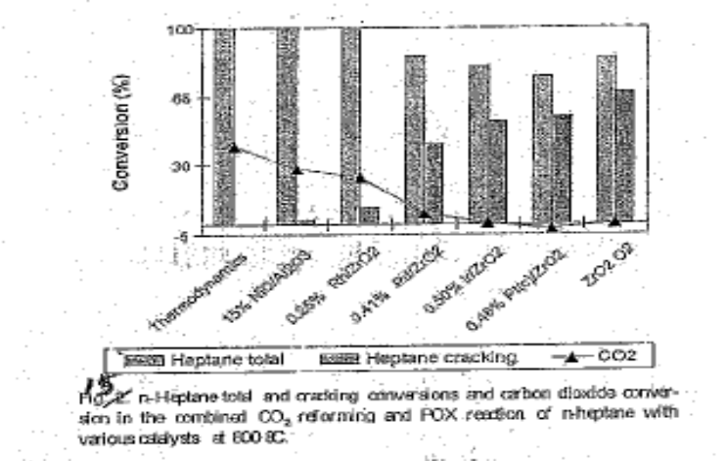
n-Heptane and cracking conversions and carbon dioxide conversion in the combined CO2 reforming and POX reaction of n-heltane with various catalyst at 800 °C

Figure 16 (50).

considerably slower and the catalyst was relatively less stable. The reaction mechanism consisted of methane combustion followed by steam and dry reforming.
Munera et al. (57) showed that Rh/La₂O₃ catalysts are very stable for dry reforming of methane. They showed that calcined Rh/La₂O₃ solid after reduction is made of mixture of La₂O₃ and oxycarbonates on which reduced dispersed Rh clusters are sitting. The catalyst showed the presence of both Ia and II-La₂O₂CO₃ as well as both linear and bridge-bonded CO adsorbed on metallic rhodium. These observations support a reaction mechanism in which two slow steps are:
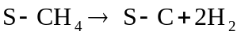 methane decomposition (52)
and
(53)
The latter reaction is surface reaction of lanthanum oxycarbonate with the carbon residue left on the surface upon methane decomposition. This reaction provides a rationale for the stability of the catalyst. Munera et al. (40) also showed that Ru (0.6%)/La₂O₂ (27%)-SiO₂ is one of the best catalysts used in the membrane reactors for the CO₂ reforming of methane. A reaction mechanism involving the chemical interaction between CO₂ and support, similar to the one proposed for 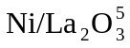 and 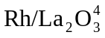 is observed in this binary support catalyst. The binary support contains lanthanum silicate. However, small amounts of lanthanum carbonates are revealed in this study. Munera et al. (57) estimated that about 2% of the La₂O₃ load could be available to form carbonates in the presence of CO₂. The study concluded that Rh is better dispersed in this binary support.
Basini and Sanfilippo (89), Zhang et al. (90), and Wang and Ruckenstein (91) examined Rh dispersed on numerous supports. Basini and Sanfilippo (89) studied Rh, Ru, and Ir deposited from tetrametallic dodecacarbonyl clusters onto low surface area polycrystalline α-Al₂O₃, MgO, CeO₂, La₂O₃, and TiO₂. The catalytic reactions were studied in conditions in which the carbon formation quickly deactivates Ni-based catalyst but does not deactivate noble metals based materials. The study was done in the temperature range of 300 °-750 °C. The study showed the formation of highly reactive oxidic species from the dissociation of CO₂ and they inhibit the production of large carbon aggregates. Zhang et al. (90) studied the effects of carrier and metal particles size on the catalytic performance (initial intrinsic activity and deactivation characteristics) of Rh in dry rerforming of methane. The specific activity of Rh catalysts was found to strongly depend on the carrier employed to disperse the metal, decreasing in the order yittria-stabilized zirconia YSZ > Al₂O₃ > TiO₂ > SiO₂ > La₂O₃ > MgO, a result that correlates directly with the acidic characteristics of the carrier. The initial intrinsic activity and rate of deactivation of Rh were also found to be sensitive to the metal particle size, in the range of 1-6 nm. Both activity and rate of deactivation were found to decrease with increasing metal particle size. However, the degree of these dependencies was found to be largely affected by the nature of the carrier, suggesting that the dependence of activity and the rate of deactivation on metal particle size is likely to be related to metal-support interactions. While relatively high deactivation rates were observed over Rh supported on TiO₂ and MgO, lower deactivation rates were observed over Rh supported in YSZ, Al₂O₃, La₂O₃, and SiO₂. The study indicated that at least three factors contribute to the catalyst deactivation: carbon deposition, metal sintering, and poisoning of surface Rh sites by species originating from the carrier. The importance of each of these factors was found to be determined by the nature of the carrier. Wang and Ruckenstein (91) studied Ru (0.5 wt%) on two kinds of oxides, reducible (CeO₂, Nb₂O₃, Ta₂O₅, TiO₂, and ZrO₂) and irreducible (Y-Al₂O₃, La₂O₃, MgO, SiO₂, and Y₂O₃) supports. Among the irreducible metal oxides, Y-Al₂O₃, La₂O₃, and MgO provided stable catalytic activities and the activities increased in the sequence: La₂O₃ < MgO ≈ Y-Al₂O₃. Deactivation occurred for SiO₂ and Y₂O₃ supported catalysts. The stability is largely caused by the strong interactions between Rh₂O₃ and support. Among the reducible oxides, Nb₂O₃ provided a low activity, ZrO₂ and CeO₂ provided a very long activation period and deactivation occurred over Ta₂O₃ and TiO₂. Most reducible oxides provided much lower yields to CO and H₂ than the irreducible ones, and they are not suitable supports for Rh in dry reforming. In summary, Wang and Ruckenstein (59) indicated that MgO and Y-Al₂O₃ are the most promising supports. They provided a stable high activity with a CO yield of 83-85% and H₂ yield of 76-79%.

3.B.6. SUMMARY
Rostrup-Nielsen and Bak Hansen (78) have given an excellent review of dry reforming over transition metal catalysts such as Ni, Ru, Rh, Pd, Ir, and Pt which include all noble metals analyzed above. They studied the equilibrium for methane decomposition, activity of reforming, carbon formation as well as selectivity of the carbon formation. They found that replacing steam by CO₂ had no significant impact on the reforming mechanism. The CO₂ reforming is slower than steam reforming. This is shown in Figure 17 for various catalysts and as functions of CO heat of adsorption. This, however, has little impact on practical reforming operation, where the reverse water-gas shift reaction will soon make steam available for faster steam reforming route. The typical activity trends for various metals for steam and CO₂ reforming are shown in Figures 18 and 19. The activity trend observed for stream reforming and Ru and Rh being the most active metals is less pronounced for CO₂ reforming.

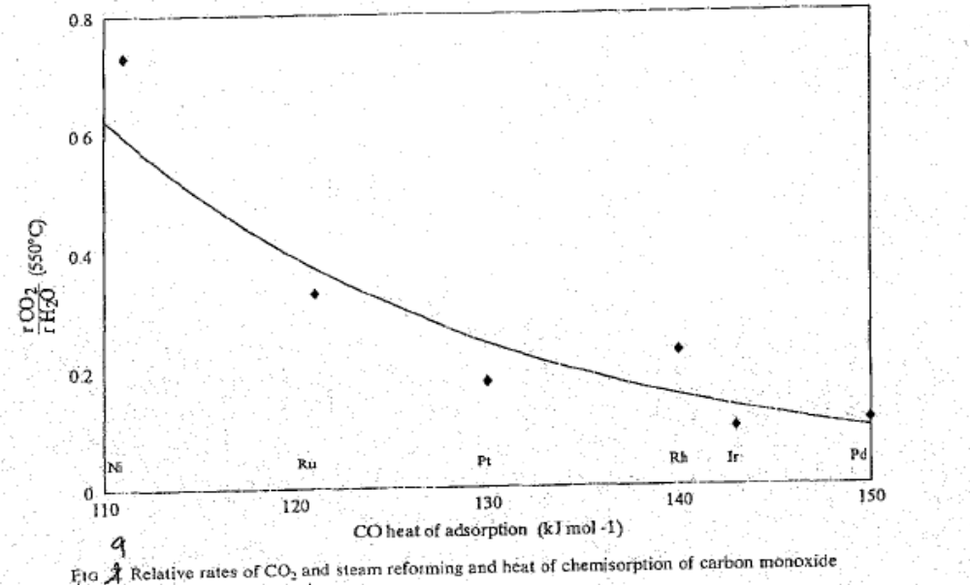
Relative rates of CO2 and steam reforming and heat of chemisorption of carbon monoxide.
Figure 17 (78).

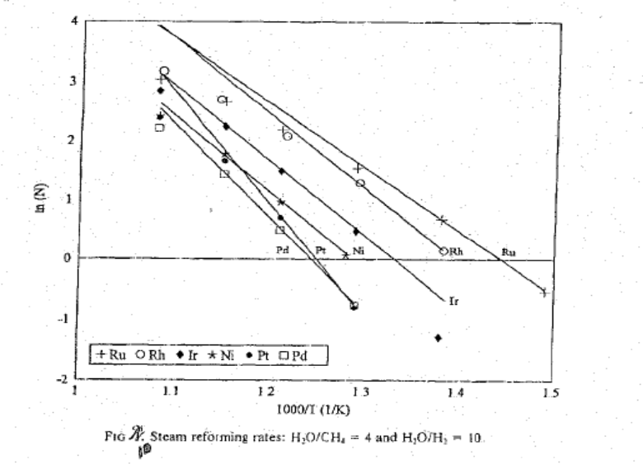
Steam reforming rates : H₂O/CH₄ = 4 and H₂O.H₂ = 10
Figure 18 (78).

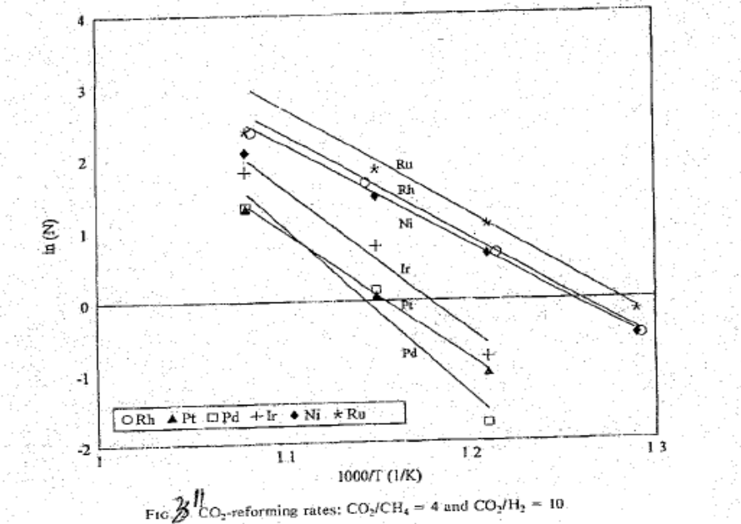
CO₂ reforming rates : CO₂/CH₄ = and CO₂/H₂ = 10
Figure 19 (78).

3.C DUAL FUNCTIONAL COMPOSITE CATALYSTS
One of the reasons for growing interest in dry reforming is that CH₄ and CO₂ are the main constituents of biogas produced extensively by various anaerobic biological waste treatments which is often of pure quality but its vaporization can be enhanced through this process.
The catalysts employed for this reaction are of dual nature. Namely, they are consisted of a metal, either noble-like Ru, Rh, Pt, Pd, or transition one like Ni, Co, Cu, and an oxidic phase-like SiO₂, Al₂O₃, MgO, BaO, CeO₂, La₂O₃, TiO₂, and ZrO₂. The combination of these components leads to various dual catalysts but it has recognized that the Ni- and Pt-based ones provide the best activity. The most important difference between catalysts based on those two metals is the resulting carbon deposition, either amorphous or in the form of non-fibers, which is higher on Ni and for this reason it appears as more active.
The reaction mechanism on such catalytic solids appears diverse, but there is a general consensus that CH₄ and CO₂ are adsorbed in dissociated form on the metallic and the oxidic catalyst. Unfortunately, the resulting equations describing the kinetic appear often very diverse. Such kinetics are always referred to the rate of methane conversion and not the rate of CO₂ conversion. The reason for this is that CO₂ is converted by reaction with CH₄ as well as by reverse water-gas shift conversion which has not been studied extensively. Recent investigations have focused on bi- and tri-metallic metals supported on one or more supports. Most of these studies, however, have used Ni as one of the active metals implying that from practical standpoint, Ni is still the best metal for reforming reactions. A brief review of numerous composites of Ni catalysts is presented below.

3.C.1 PT-NI CATALYSTS
Pt-Ni catalysts have been tested for a-Al₂O₃ and a-Al₂O₃-ZrO₂, ZrO₂ and zeolite ZSM-5 supports. Pompeo et al. (26) showed that all catalysts have good activity although Ni based catalysts were more active than Pt based catalysts, the selectivity measured at 600°C expressed by the molar ratio of H₂/CO was approximately 1.0 for both catalysts. Pt/ZrO₂, Pt/Al₂O₃-ZrO₂ and Ni/a-Al₂O₃-ZrO₂ showed lower deactivation levels than Ni/ZrO₂ or Ni and Pt supported on a-Al₂O₃.compared with Ni and Pt Catalyst supported on a- Al₂O_{3.} The lowest deactivation levels observed in Ni and Pt catalyst supported on Al₂O₃ can be explained by an inhibition reaction which leads to carbon deposition in systems having ZrO₂ supports. These results suggest that ZrO₂ promotes the gasification of adsorbed intermediates which are precursors of carbon formation and responsible for the main deactivation mechanism in the dry refoming reaction.
Pawslec et al. (44) showed that the addition of a small amount of Pt (0.5 wt%) to the Ni catalyst leads to the formation of small nano-sized NiO particles and easy reduction of NiO on the ZSM-5 catalyst. They found that the amount of precursor plays an important role on the surface and the catalytic properties of bi-metallic catalysts. The improvement of catalytic activity and stability observed for bi-metallic catalysts was attributed to the increase in Ni metallic dispersion caused by intimate contact between nickel and platinum at a Ni loading of 6 wt%. Arishtirova et al. (8) also showed that the introduction of a small amount of Pt (0.3 to 0.5 wt%) into the Ni catalyst leads to a decrease in the NiO size. Its easy reduction and a uniform distribution of nickel metal particles.

3.C.2 Ru-NI CATALYSTS
Tsyganok et al. (56) examined various combinations of bi-metallic catalysts Ru-M (M = Cr, Fe, Co, Ni, and Cu) supported on Mg-Al mixed oxides. The catalysts were prepared by repeated calcination–rehydration cycles to take advantage of “memory effect” i.e. on the ability of Mg-Al mixed oxide to reconstruct a layered structure upon rehydration with an aqueous solution. Among all bi-metallic catalysts tested by these authors, RuNi/MgA10_{x} appeared to be most attractive for dry reforming reaction because it demonstrated the highest activity and selectivity to syngas no any induction time when generated in situ, a suitable clausability and a low coking capacity.

3.C.3 Rh-NI CATALYSTS
Martha et al.(92) examined kinetics of CO₂ reforming of methane over Ni-Rh-Al₂O₃ catalysts in the temperature range of 778-898K at atmospheric pressure. No evidence of coke formation or deactivation was found during the kinetic study. The experimental data indicated that the RWGS reaction influences the global system and it should be condensed at equilibrium. Authors investigated twenty-seven different kinetic models for the dry reforming reactions.
Hou et al.(36) showed that for dry reforming of CH₄, noble metal (Rh, Ru, Pt and Ir) catalysts showed excellent coke resistance than Ni and Co. Meso-porous Al₂O₃ supported Rh and small amounts of Rh-promoted Ni catalysts exhibited a higher activity and excellent coke resistance ability than pure Ni/Yac3-8. Pulse CO adsorption experiments revealed that the dispersion of Rh is low on Al₂O₃ due to its limited surface area, while RH dispersed efficiently on the high surface of meso-porous Al₂O₃ (Yac3-8). On Rho-1Ni/Yac3-8, no coke deposition was detected even at high space velocity. H₂-TPR characterization indicated that Rh improved the reducibility of Ni, which might increase the reforming activity of the catalysts. Tsuji et al. (93) showed that CO₂ decomposition into carbon is accelerated by Rh, Pt or Ce impregnation into Ni(II) bearing ferrite.
3.C.4 NI-K CATALYSTS
Carbon deposition or coking is the major factor that influences catalyst activity and stability and that leads to deactivation carbon filaments and amorphous carbon formed on nickel catalysts during carbon dioxide reforming of methane. Several factors including temperature, CO₂/CH₄ ratio, catalyst support, metal particle size, metal morphology and chemical properties affect the carbon structure and coke growth mechanism. So far, most work on carbon filament growth mechanism and kinetics has been centered on studies of CH₄ cracking of CO disproportionate. Pechimuthu et al. (17) showed that 13.5Ni-2K/10CeO₂-Al₂O₃ catalyst exhibited very stable catalytic performance for the reforming reactions at 650, 700 and 750 °C
Juan-Juan et al. (54) showed that the presence of K in Ni/Al₂O₃ catalysts hinders the accumulation of coke on the catalysts surface during the dry reforming of methane, but produces a decrease in catalyst activity. There is, however, an optimum amount of K (0.2 wt% K₂O) that leads to catalyst with a very low coke deposition and high catalyst activity (more that 90% reduction in coke deposition and less that 10% decrease in the catalyst activity). In the presence of potassium, the coke deposits do not activate the catalysts because Ni particles are on the top of carbon filaments formed during reaction. Significant carbon deposits, however, can plug the reactor.
Juan-Juan et al. (54) also showed that the amount of potassium allows (i) increased reducibility of Ni species by hydrogen because it modifies the interaction between Ni-oxide into Al₂O₃ supports and (ii) potassium migrates from the support to the Ni surface and neutralizes a fraction of active sites and (iii) potassium catalyzes the gasification of the coke formed during reaction without modification of its structure and (iv) potassium does not modify either size or the structure of the Ni particles. Shamsi (33) examined partial oxidation and dry reforming of methane to synthesis gas over Ca²⁺/Ni⁺/K⁺ (Na⁺) catalysts. He found lower methane and CO₂ conversions, lower H₂/CO ratio, and higher carbon deposition at higher pressures. Lower catalyst activity observed at higher concentrations of K⁺ or Na⁺, however, as the concentrations are reduced, the catalyst activity was increased producing significantly less carbon. Also for dry reforming over K⁺ or Na⁺ promoted catalysts indicated that the carbon formed on the catalyst originated from both methane and CO₂. It appears that during oxidation of carbon deposited on Ca²⁺/Ni⁺/K⁺ catalyst oxygen reacts with catalyst first before reacting with surface carbon, providing surface oxygen for both oxygen assisted activation of methane and also for oxidation of surface carbon. However, in case of Ca²⁺/Ni²⁺/Na⁺ catalyst, the oxygen peak and the CO₂ peak are mirror images of each other, indicating that most of the oxygen consumed by the carbon deposited on the catalyst.

3.C.5 Ni-Ti CATALYST
Sun et al. (14,94) showed that contrary to the common belief Ni-Ti composite xerogel catalyst can be made with a relatively large surface area and a narrow pore size distribution using a sol-gel method by carefully optimizing the hydrolysis ratio and the acid/alkoxide ratio. It is the high-temperature calcination that results in significant drop of surface area not only for xerogel but also for aerogel materials due to collapse of pore structure and the formation of bigger crystalline particles. Adding aluminum-containing precursor to make Ni-Ti-Al composite xerogel catalyst results in large surface areas even after the sample underwent calcination at 973 K. Compared with the published catalysts, this catalyst has better selectivity and well-matched activity for CO₂ reforming of methane. Guo et al. (13,79) showed that BaTi_{0.8}Ni_{0.2}O₃ exhibited the best activity and excellent stability for partial oxidation of syngas. The study showed that the partial oxidation of methane to syngas over BaTi_{1-x}Ni_{x}O₃ catalysts principally followed the two-step reaction mechanism via combustion and reforming reactions; i.e., part of the methane was first completely oxidized to H₂O and CO₂, and then the unconverted methane was reformed with CO₂ and H₂O to form syngas.

3.C.6 Ni-Mg CATALYSTS
Choudhary et al. (30) examined tri-metallic, NiCO and Mg catalyst (NiCOMgO_{x}) supported on a commercial low surface area sintered zirconia-hafnia (94.1% ZrO₂-HfO₂) catalyst carrier showed excellent thermal stability and activity/selectivity for the dry reforming reactions along with steam reforming and catalytic partial oxidation reactions. The CO₂ conversion was strongly affected by the reaction temperature, significant CO₂ conversion (> 40%) could only be obtained at high dry reforming reaction temperature (900 °C). The typical results obtained by Choudhary et al. (30) as shown in Figure 20.
Djaidja et al. (37) showed that NiMg/Al catalysts prepared by co-precipitation method and Ni/MgO prepared by impregnation are suitable catalysts for selective dry reforming of methane producing good yields of hydrogen and carbon monoxide with high CH₄ conversion. The catalysts are remarkably active even at the lowest temperature studied (700 °C), they show a low carbon deposition even at the highest reaction temperature. A previous reduction of the solids improves their catalytic activity. The activity results indicated that CH₄ conversion and CO and H₂ selectivity approach that predicted by thermodynamics. The catalytic behavior of these catalysts could be explained in terms of the reducibility and also of the good dispersion of Ni species due to the interaction between Ni and Mg-Al.
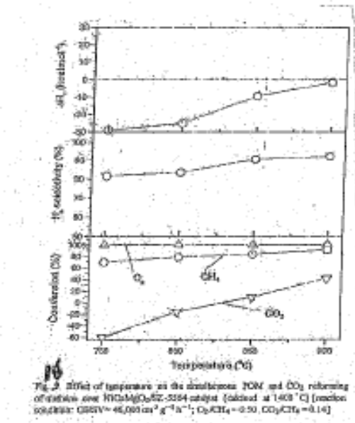
Temperature °C
Figure 20

3.C.7 Other Ni Composites
Two other Ni composites are worth mentioning. deLima and Assaf (31) considered Ni-Fe on perovskite-type oxides LaNi_{(1x)} Fe_{x}O₃ (x = 0.2, 0.4, and 0.7) perovskite-type catalysts were modified by the partial substitution of Ni by iron aiming to increase the stability and resistance to carbon deposition during the methane dry reforming reaction. The study showed that a suitable combination of precipitation and calcination steps could result in oxides with the desired structure and with improved properties. The partial substitution of Ni by Fe in the perovskite structure resulted in decreasing rates of conversion of both reactants. However, the stability of the catalyst during the reaction was highly increased. These substituted catalysts were shown to be stable and the LaNi_{0.8}Fe_{0.2}O₃ catalyst calcined at 800 °C for 5 h was the most active in the reaction conditions.

Kang et al. (42) examined tri-reforming catalyst NiO-YSZ-CeO₂ for dry reforming reaction. This catalyst showed higher activity than the commercial catalysts. The conversions of CH₄ and CO₂ over NiO-YSZ-CeO₂ catalyst were 100% above 800 °C. No NiC phase was detected on the surface of NiO-YSZ-CeO₂ after the tri-reforming, but it was detected after dry reforming reaction. The tri-reforming of CH₄ is more desirable process to produce syngas than the dry reforming. The results suggest that the tri-reforming of CH₄ over NiO-YSZ-CeO₂ catalyst can be applied to the production of high valued chemicals and fuel processor of SOFC and MCFC system.

4. PROCESS CONSIDERATIONS
4.A. ISSUES
As shown in previous section, the catalytic reduction of carbon dioxide by hydrocarbons and alcohols leads to a variety of products and the transformation to syngas (CO + H₂) meet with different degree of success depending upon the operating conditions and the nature of the catalyst. The major issues with dry reforming are (a) endothermic nature of reaction requiring high energy input for the reaction process, (b) difficulty in igniting the reaction at low temperature (lower than about 500 °C), and (c) requiring very high temperature (> 650 °C) to reduce coke deposition on the catalyst.

More recent investigations on dry reforming have taken the following directions: (a) examine in details nickel, other transition metals such as Rh, Rd, Pt, etc., and bi- or tri-metallic catalysts; (b) examine different catalyst support systems and their interactions with the metals; and (c) examine mixtures of dry and steam reforming or dry reforming and partial oxidation or consider the oxy-forming which includes all these processes (steam and dry reforming and partial oxidation) occurring simultaneously. The overall objective has been to device a process which is (a) less coke depletion on the catalyst such that the catalyst is active and stables for a long period, (b) catalyst ignites at low temperature as possible, (c) the entire process is heat efficient, (d) high conversion of CO₂ and hydrocarbons are achieved, and (e) major products are carbon monoxide and hydrogen. As indicated earlier, the last objective is a particular problem when hydrocarbon contains two or more carbon numbers.

4.B. POTENTIAL APPLICATION FISCHER-TROPSCH (F-T) OFF GASES
On significant application of dry reforming is F-T off gases to produce syngas which can be recycled back to the F-T process. The typical composition of F-T off gases is given in Tables 9a and 9b (95). While CO₂ concentration in F-T off gases is generally low, additional CO₂ can be injected into this stream. Generally, F-T off gases are at 250 to 300 °C. These gases can be further heated by transforming some heat from the gasifier. It is also possible to increase the pressure of F-T gases such that supercritical conditions are achieved (for CO₂ pressure required is about 1100 psi). Since F-T off gases do not contain impurities, catalytic reduction of CO₂ by hydrocarbons is attractive. Typical product distribution of F-T SASOL process is described in

Product | Fixed Bed | Synthol (fluidized bed)
Gasoline
Middle distillate
Heavy Oil and Wax
Oxygenated compounds

Table 9a (95)
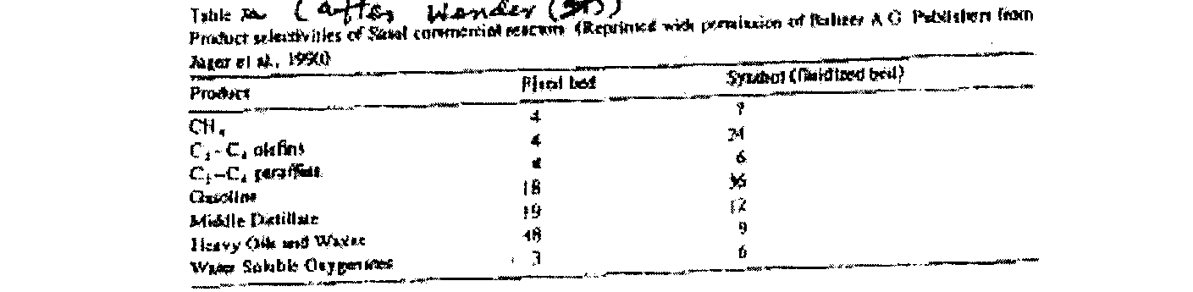

Table 9b (95)
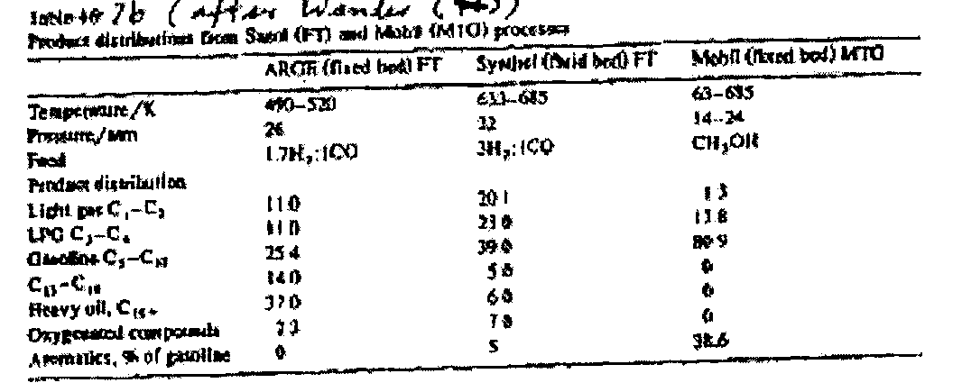
4. C. HEAT OPTIMIZATION (DRY VERSUS OXY-FORMING)
The heat of reaction for dry reforming as compared to combustion, partial oxidation (POx) and steam reforming (SR) is given in Figure 21 in kJ/mol. As seen from the figure, the dry reforming reaction is highly endothermic which necessitates the careful integration of this reaction into any process scheme.
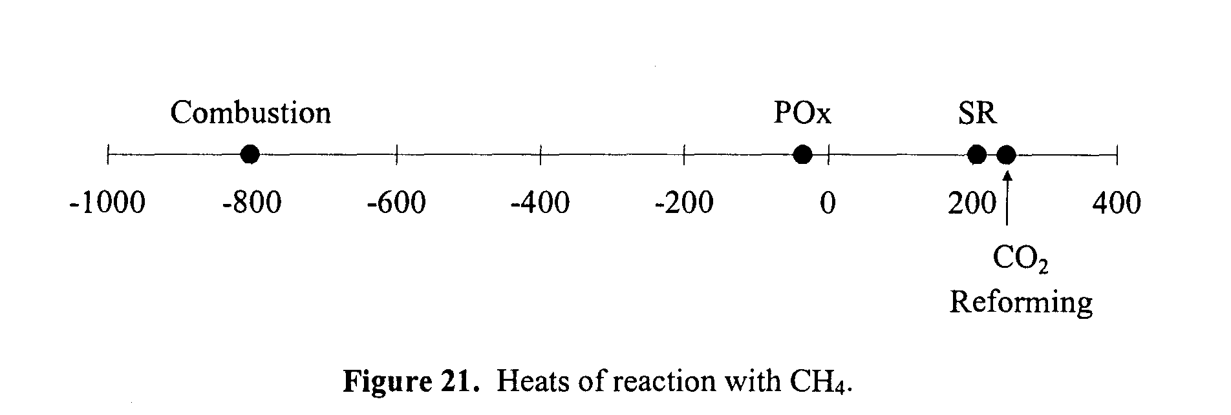

Molecular oxygen may be added to the dry reforming reaction to provide additional heating. Similarly, steam may be added to minimize carbon deposition. The addition of oxygenated compounds, other than C02, is known as oxy-forming and provides a convenient method to assist with process integration and temperature approach matching as well as maintaining the catalyst in a clean and carbon-free state. The extent to which oxygenates are added to the dry reforming reaction is determined strictly by the process conditions and the catalyst employed.

4. D. SUPERCRITICAL DRY REFORMING
While supercritical processes are generally not considered to be economical because of high capital costs associated with high-pressure equipment and high operating costs associated with the compression or pumping of supercritical medium, unique properties of supercritical fluids offer some interesting possibilities.
As shown in Figure 22 for supercritical CO₂, at critical temperatures and pressure, there is no distinction between gas and liquid phases. For both CO₂ and water, heat of vaporization becomes negligible at P_{c} and transport properties such as density, viscosity, diffusivity, heat capacity, dielectric constant, etc., become very favorable. For supercritical conditions for water, the H⁺ ion concentration can be 30 times higher than at ambient conditions; water possesses the properties of an acid/base catalyst at supercritical conditions.
In conjunction with catalysis, a supercritical fluid can dissolve unwarranted hydrocarbons from the catalyst surface into the supercritical fluid phase. Supercritical fluids have better capacity to handle heat due to high heat capacities. The adsorption/desorption phenomena can be better handled in a supercritical fluid due to higher solubilities. The oligomeric coke precursors or sulfur species can be easily described by the supercritical fluids.
Supercritical reforming of hydrocarbons offers a possible way to convert hydrocarbons at lower temperatures than in conventional industrial reforming processes. Watanabe et al. (96,97) studied partial oxidation of n-C₁₆ in SCW at 400 to 420 °C and 400 atm and found that the yields of H₂ and CO increased with increasing water density. Yields of H₂ were 4 times better with NaOH and 1.5 times better with ZrO₂ compared to reaction without a catalyst. Supercritical fluids gave increased pore accessibility, enhanced catalyst ability to coking and increased desired product selectivity.
So far, most supercritical reforming has been examined for water. Pinkwar et al (98) examined reforming of diesel oil and Shekawat et al (99) studied catalytic reforming of liquid hydrocarbons fuels for fuel cell applications. They concluded that supercritical reforming of hydrocarbons at lower temperatures than in conventional industrial reforming process. They also showed that hydrogen yield increases by using commercial catalysts even if they are not optimized for these conditions.
Significant research on reforming of methanol in supercritical water has been reported. Boukis et al. (100) reported that for high conversion rates in shorter residence time, it is necessary to increase the reaction temperature to 600 °C. The heavy metals of the inner surface have a significant influence on the conversion and the composition of the reaction products. Under supercritical conditions, catalyst affects both methanol decomposition and water-gas shift reaction. More hydrogen is produced under supercritical conditions. Gadhe and Gupta (101) showed that supercritical reforming of methanol with water produces CO, CH₄, CO₂, and H₂. The factor favoring methanation reactions are high pressure, high residence time, and low steam to carbon ratio. Methanation reaction can be reduced greatly by lowering the residence time so that equilibrium is not allowed to be reached. Ni-Cu reduces the CH₄ formation. The addition of K₂CO₃ and KOH in aqueous methanol also reduces the CH₄ formations. Taylor et al. (102) also showed that in the temperature range of 550 °-700 °C and 27.6 Mpa pressure, H₂ rich product steam with low CH₄ and equilibrium ratio of CO and CO₂ can be produced. They indicated that the reactions occur in two steps: initially CH₃OH decomposes to CO and H₂, and subsequently, CO is converted to CO₂ by water-gas shift reaction. Higher steam to carbon ratios reduce the concentration of CO in the product gas. Both reaction steps mentioned above are kinetically limited for temperatures less than 700 °C. Under all conditions CH₄ formation was kinetically limited. Taylor et al. (102) also showed that for ethanol, more CH₄ was formed than H₂. Ethylene glycol also produced more methane and CO than what was produced in methanol reforming. Acetone and diesel fuel produced black liquor and plug the reactors.
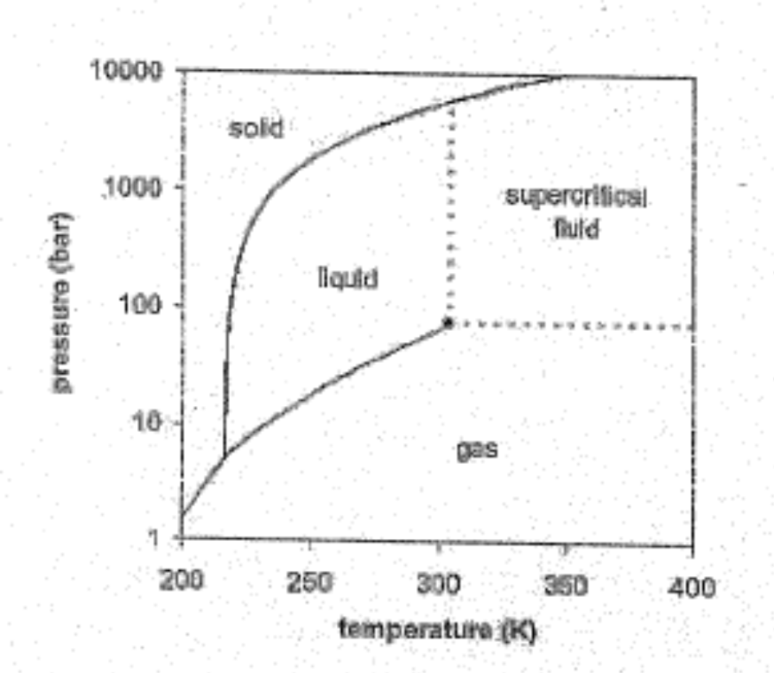
Figure 22. Phase predominance diagram for CO₂.

5. CONCLUDING REMARKS
In recent years, dry reforming is becoming more important because of the need to CO₂ into more useful products. There is a lot of similarity in the reaction mechanisms and catalyst and operating conditions among dry reforming, steam reforming, and partial oxidation of hydrocarbons. In fact, simultaneous dry and steam reforming processes are unavoidable because of water-gas shift reaction. Many studies have indicated that dry reforming first goes to the production of H₂O through water-gas shift reaction and this results in subsequent steam reforming process. Partial oxidation of methane is relevant because during dry reforming, methane decomposition and oxidation also simultaneously taking place. From a commercial standpoint, "oxy-forming" which is a combination of dry and steam reforming along with partial oxidation should be investigated. One advantage of "oxy-forming" process is the heat balance between exothermic oxidation process and endothermic steam and dry reforming processes.
The literature has shown that generally dry reforming is a somewhat slower process than steam reforming. Both processes do not ignite at low temperatures (< 500 °C). The combination of partial oxidation along with reforming process can help this ignition process (103,104). Because of these reasons, our recommendation is to investigate "oxy-forming" process rather than dry reforming in the future.
The success of the CO₂ conversion depends on three factors: catalyst activity, catalyst stability (which depends significantly on the coke formation and the nature of the coke), and an efficient heat transfer operations. While these are numerous catalysts examined in the literature, it is clear that nickel catalyst is still the most practical from an economic point of view at the commercial scale. Noble metal catalysts such as Rh, Ru, and Pt are more active and perhaps more stable, but they are too expensive to be of commercial value. Our recommendation is to focus on bi-metallic catalysts such as Ni-Ru in the future study. Ru is about 40-50 times less expensive than Rh and, therefore, it will carry more practical viability for the commercial process.
The nature of the catalyst support is also very important (105-107). Support often interacts with metals and because of that it is often considered as part of catalyst. The best situation is very active metals are uniformly and in small sizes distributed along support and they do not migrate or sinter during high-temperature reforming process. Perovskite support offers special attraction because in this case metals are uniformly and tightly distributed in the support lattice. The catalyst must be a basic in nature but literature has shown that too much basicity do not help the reforming process. Along with Al₂O₃, lanthanum, cerium, and zirconium oxides need to be examined. Just like mixed metals, mixed supports should also be considered.
Finally, an investigation of the oxy-forming process under supercritical conditions should be considered. As indicated above, supercritical conditions help alleviate heat transfer problems. Supercritical CO₂ is a very convenient fluid because of its relatively low critical temperature and pressure. Supercritical CO₂ can enhance solubility of carbonaceous compounds which can help catalyst activity and stability. Also, because of its relatively low pressure and temperature conditions, supercritical CO₂ operation has commercial viability.

/////////////////////////////////////////Data removed from earlier in the document.

compounds, e.g. organometallic reagents such as Grignard reagents readily react with CO₂ even at a low temperature. Water, alkoxides, and amines also add to CO₂ in similar manners to produce compounds with a carboxyl or carboxylate group. Further reactions of these species with electrophiles lead to the formation of organic carbonates and carbamates. On the other hand, reactions of low valent metal complexes (mainly nickel(0) and palladium(0)) with CO₂ and unsaturated compounds lead to the formation of five-membered metallalactones (Table 1) because the valence of the metal increases by two, this type of reaction is called an “oxidative cycloaddition”. Hence, reactions involving CO₂ can be categorized into two patterns: (1) formation of a carboxyl group through nucleophilic attack (pattern a) and (2) generation of a five-membered ring through oxidative cycloaddition (pattern b) (Table 1).
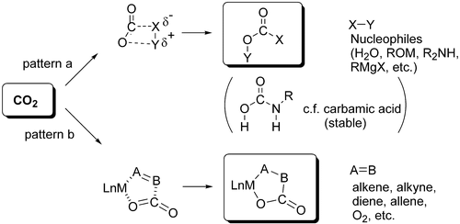

Table 1 Typical Transformation of Carbon Dioxide
At the present time, a number of large-scale processes utilizing CO₂ have found industrial use: the production of calcined soda by the Solvay method, the production of urea (carbamide), the production of salicylic acid. Carbon dioxide has been introduced into complexes of transition metals with organic ligands (1, 2, 3) whose decomposition can give organic acids, esters, lactons, etc. Bonding of CO₂ molecules as ligands in transition metal complexes is also known (4, 5). The synthesis of organic carbonates from CO₂ is a quickly developing field of CO₂ chemical use. Table 2 summarizes examples of organic synthesis starting from CO₂.
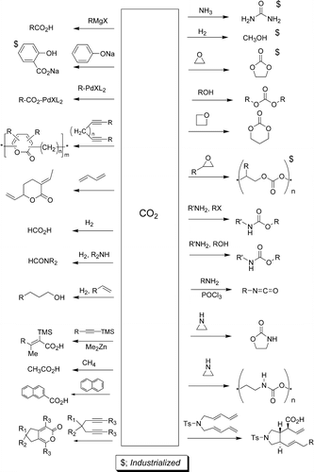

Table 2 Transformation of Carbon Dioxide

REFERENCES

- M. Aresta, G. Forti, Eds., ”Carbon dioxide a source of carbon, biochemical and chemical use”; NATA ASI Series, Series C; D. (1986), Reidel Publication Co. Dordrecht, Holland 421 pp.

- P. Braunstein, D. Matt, D. Nobel, ”Reactions of carbon dioxide with carbon-carbon bond formation catalyzed by transition metal complexes, Chemical Review, (1988) pp.88 747-764.

- W. Keim, Ed. Catalysis in C1, Chermistry, D. Reidel Publ. Co; Dordrecht, Holland (1983).

- G.S. Breslow, P.B. Hitchcock, M.F. Laptest, ”A novel carbon dioxide complex: synthesis and crystal structure of N6 (Ŋ-C5H4Me) 2 (CH2 SiMe3) (Ŋ²-CO) Journal of Chemistry Social Chemistry Communication, (1981) 21, 1145-1146.

- G. Fachinelti, C. Floriani, P.F. Zanazzi, Bifunctional activation of carbon dioxide
synthesis and structure of reversible CO1 carrier, Journal of American Chemical Society (1978), 100, 7405-7407.

- F. Barrai, T. Jackson, N. Whitmore, and M. J. Castaldi. The role of carbon
deposition on precious metal catalyst activity during dry reforming of biogas. Catalysis Today, 2007 129:391-396.

- L. B. Raberg, M. B. Jensen, U. Olsbye, C. Daniel, S. Haag, C. Mirodatos, A. O. Sjastad, Propane dry reforming to synthesis gas over Ni-based catalysts: influence of support and operating parameters on catalyst activity and stability. J. of Catalysis, 2007. 249:250-260

- K. Arishtirova, B. Pawelec, R. N. Nikolov, J. L. G. Fierro, and S. Damyanova.
Promoting effect of Pt in Ni-based catalysts for CH4 reforming. Reaction Kinetics,
Catalysis Letters, 2007. 91(2):241-248.

- A. Dominguez, Y. Fernandez, B. Fidalgo, J. J. Pis, and J. A. Menendez. Biogas to
syngas by microwave-assisted dry reforming in the presence of char. Energy and Fuels,
2007. 21:2066-2071.

- B. Mhadeshwar, and D. G. Vlachos. A catalytic reaction mechanism for methane partial
oxidation at short contact times, reforming and combustion and for oxygenate
decomposition and oxidation on platinum. Ind. Eng. Chem. Res. 2007. 46:5310-5324.

- S. Eriksson, S. Rojas, M. Boutonnet, and J. L. G. Fierro. Effect of Ce-doping on
Rh/ZrO2 catalysts for partial oxidation of methane. Applied Catalysis A: General, 2007.
326:8-16.

- L. Yin, S. Wang, H. Lu, J. Ding, R. Mostofi, and Z. Hao. Simulation of effect of
catalyst particle cluster on dry methane reforming in circulating fluidized bed. Chemical
Engineering Journal, 2007. 131:123-134.

- J. Guo, H. Lou, and X. Zheng. The deposition of coke from methane on a Ni/MgAl2O4
catalyst. Carbon, 2007. 45:1314-1321.

- H. Sun, H. Wang, and J. Zhang. Preparation and characterization of nickel-titanium
composite xerogel catalyst for CO2 reforming of CH4. Applied Catalysis B:
Environmental, 2007. 73:158-165.

- L. V. Galaktionova, L. A. Arkatova, T. S. Kharlamova, L. N. Kurina, Yu Naiborodenko,
N. G. Kasatskii, and N-N. Golobokov. Formation of compaction products in methane dry reforming on a Ni-containing catalyst. Russian J. of Physical Chemistry A, 2007.
81(10):1718-1721.

- Z. Boukha, M. Kacimi, M. F. R. Pereira, J. L. Faria, J. L. Figueiredo, and M. Ziyad.
Methane dry reforming on Ni-loaded hydroxyapatite and fluroapatite. Applied Catalysis A: General, 2007. 317:299-309.

- N. Pechimuthu, K. K. Pant, and S. C. Dhingra. Deactivation studies over
Ni-K/CeO2-Al2O3 catalysis for dry reforming of methane. Ind. Eng. Chem. Res., 2007.
46:1731-1736.

- Topalidis, D. E., Petrakis, A. Ladavos, L. Loukatzikou, and P. J. Pomonis. A
kinetic study of methane and carbon dioxide interconversion over 0.5% Pt/SrTiO3 catalysts. Catalysis Today, 2007.127:238-245.

- E. Promaros, S. Assabumrungrat, N. Laosiripojana, P. Praserthdam, T. Tagawa, and
S. Goto. Carbon dioxide reforming of methane under periodic operation. Korean J. of
Chem. Eng,. 2007. 24(1):44-50.

- J. F. Munera, S. Irusta, L. M. Cornaglia, E. A. Lombardo, D. V. Cesar, and M. Schmal.
Kinetics and reaction pathway of the CO2 reforming of methane on Rh supported on
lanthanum-based solid. J. of Catalysis, 2007. 245:25-34.

- Y. Cui, H. Zhang, H. Xu, and W. Li. Kinetic study of the catalytic reforming of CH4 with CO2 to syngas over Ni/α-Al2O3 catalyst. The effect of temperature on the reforming
mechanism. Applied Catalysis A: General, 2007. 318:79-88.

- S. Murata, N. Hatanaka, K. Kidena, and M. Nomura. Improvement of lifetime of
Ni/mordenite catalysts for CO2 reforming of methane by support modification with alumina and Co-K loading. J. of the Japan Petroleum Institute, 2006. 49(5):240-245.

- S. Haag, M. Burgard, and B. Ernst. 2 Beneficial effects of the use of a nickel membrane
reactor for the dry reforming of methane: comparison with thermodynamic predictions. J.
of Catalysis, 2007. 252:190-204.

- G. Goula, V. Kiousis, L. Nalbandian, and I. V. Yentekakis. Catalytic and
electrocatalytic behavior of Ni-based cermet anodes under internal dry reforming of
CH4 + CO2 mixtures in SOFCs. Solid State Ionics, 2006. 177:2119-2123.

- L. Pelletier, and D. S. Liu. Dirksen. Stable nickel catalysts with alumina-aluminum
phosphate supports for partial oxidation and carbon dioxide reforming of methane. Applied Catalysis A: General, 2007. 317:293-298.

- F. Pompeo, N. N. Nichio, M. M. V. M. Souza, D. V. Cesar, O. A. Ferretti, and M. Schmal.
Study of Ni and Pt catalysts supported on a-Al2O3 and ZrO2 applied in methane
reforming with CO2. Applied Catalysis A: General, 2007. 316:175-183.

- G. Goncalves, M. K. Lenzi, O. A. A. Santos, and L. M. M. Jorge. Preparation and
characterization of nickel-based catalysts on silica, alumina, and titania obtained by sol-gel method. J. of Non-Crystalline Solids, 2006. 352:3697-3704.

- S. Yokota, K. Okumura, and M. Niwa. Strong inhibition effect of sulfur impurities
in alumina supports on the catalyst activity of Rh in the CH4-CO2 reforming reaction.
Applied Catalysis A: General, 2006. 310:122-126.

- Y. Nagavasu, K. Asai, A. Nakavarma, S. Iwamoto, E. Yagasaki, and M. Inoue. Effect of
carbon dioxide cofeed on decomposition of methane over Ni catalysts. J. of the Japan
Petroleum Institute, 2006. 49(4):186-193.

- V. R. Choudhang, K. C. Mondal, and T. V. Choudhang. Methane reforming over a
high temperature stable–NiCoMgOx supported on zirconia-hafnia catalysts. Chemical
Engineering Journal, 2006. 121:73-77.

- A. M. O'Connor, Y. Schuurman, J. R. H. Ross, and C. Mirodatos. Transient studies
of carbon dioxide reforming of methane over Pt/ZrO2 and Pt/Al2O3. Catalysis Today, 2006. 115:191-196.

- C. Olafsen, Daniel, Y. Schuarman, L. B. Raberg, U. Olsbye, and C. Mirodatos. Light
alkanes CO2 reforming to synthesis gas over Ni-based catalysts. Catalysis Today, 2006
115:179-185.

- Shamsi, Partial oxidation and dry reforming of methane over Ca/Ni/K (Na)
catalysts. Catalysis Letters. 2006109(3-4):189-193.

- J.Gao, Z.Y. Hou, K. Shen, H. Lou, J.H. Fei, X.M. Zheng, “Autothermal reforming and
partial oxidation of methane in fludized reactor over highly dispersed Ni catalyst prepared
from Ni complex”. Chinese J. of Chemistry, 2006. 24(6):721-723.

- S. M. de Lima, J. M. Assaf, M. A. Pena, and J. L. G. Fierro. Structural features of
La1oxCexNiO3 mixed oxides and performance for the dry reforming of methane. Applied Catalysis A: General, 2006. 311:94-104.

- Z. Hou, P. Chen, H. Fang, X. Zheng, and T. Yashima. Production of synthesis gas
via methane reforming with CO2 on noble metals and small amount of noble- (Rh)
promoted Ni catalysts. Int. Journal of Hydrogen Energy, 2006. 31:555-561.

- S. Libs Djaidja, A. Kiennemann, and A. Barama. Characterization and activity
in dry reforming of methane on NiMg/Al and Ni/MgO catalysts. Catalysis Today, 2006.
113:194-200.

- N. Sahli, C. Petit, A. C. Roger, A. Kiennemann, S. Libs, and N. M. Bettahar. Ni catalysts
from NiAl2O4 spinel for CO2 reforming of methane. Catalysis Today, 2006. 113:187-193.

- S. P. Jiang, X. J. Chen, S. H. Chan, and J. T. Kwok. GDC-impregnated
La0.75Sr0.25…Cr0.5Mn0.5…O3 anodes for direct utilization of methane in solid oxide fuel cells. J. of the Electrochemical Society, 2006. 153:A850-A856.

- J. F Munera, L. M. Cornaglia, D. V. Cesar, M. Schmal, and E. A. Lombardo.
Kinetic studies of the dry reforming of methane over Rh/La2O3-SiO2 catalyst. Ind. Eng.
Chem. Res. 2007. 46:7543-7549.

- L. Paturzo, F. Gallucci, and A. Basile. A Pd/Ag tubular membrane reactor for
methane dry reforming: a reactive method for CO2 consumption. Desalination, 2006.
200:684-685.

- J. S. Kang, D. H. Kim, S. D. Lee, S. I. Hong, and D. J. Moon. Nickel-based tri-reforming catalysts for the production of synthesis gas. Applied Catalysis A: General, 2007. 332:153-158.

- M. Martha, B. Quiroga, and A. E. C. Luna. Kinetic analysis of rate data for dry
reforming of methane. Ind. Eng. Chem. Res., 2007.46:5265-5270.

- B. Pawelec, S. Damyanova, K. Arishtirova, J. L. G. Fierro, and L. Petrov.
Structural and surface features of PtNi catalysts for reforming of methane with CO2.
Applied Catalysis A: General, 2007.323:188-201.

- M. Rezaei, S.M. Alavi, S. Sahebdelfar, and Z. F. Yan. Mesoporous nanocrystalline
zirconia powders: a promising support for nickel catalyst in CH4 reforming with CO2.
Materials Letters, 2007. 61:2628-2631.

- M. S. Rezaei, M. Alavi, S. Sahebdelfar, L. Xinmei, L. Qian, and Z. F. Yan. CO₂-CH₄
reforming over Ni catalysts supported on mesoporous nanocrystalline zirconia with high
surface area. Energy and Fuels, 2007. 21:581-589.

- B. C. Faroldi, E. Carrara, A. Lombardo, and L. M. Cornaglia. Production of
ultrapure hydrogen in a Pd-Ag membrane reactor using Ru/La2O3 catalysts. Applied
Catalysis A: General, 2007. 319:38-46.

- L.V.Yantekakis, “Open and closed-circuit study of an intermediate temperature SOFC
directly fueled with simulated biogas mixtures” Journal of Power Sources, (2006)
160(1), 422-425

- S. Assabumrungrat, N. Laosiripojana, and P. Piroonlerkgul. Determination of the
boundary of carbon formation for dry reforming of methane in a solid oxide fuel cell. J. of Power Sources, 2006.159:1274-1282.

- K. J Puolakka, S. Juutilainen, and A. O. I. Krause. Combined CO2 reforming and
partial oxidation of n-heptane on noble metal zirconia catalysts. Catalysis Today, 2006.
115:217-221.

- S. M. de Lima, and J. M. Assaf. Ni-Fe catalysts based on perovskite-type oxides for dry
reforming of methane to syngas. Catalysis Letters, 2006. 108(1-2).

- C. Cellier, B. Blangy, C. Mateos-Pedero, and P. Ruiz. Modification of catalytic
performances due to the co-feeding of hydrogen or carbon dioxide in the partial oxidation
of methane over a NiO/g-Al2O3 catalyst. Catalysis Today, 2006.112:112-116.

- K. De Oliveira-Vigier, N. Abatzoglou, and F. Gitzhofer. Dry reforming of ethanol
in the presence of a 316 stainless steel catalyst. The Can. J. of Chem. Eng., 2005. 83:978-
984.

- J.M. Juan-Juan, C. Roman-Martonez, and M. J. Illan-Gomez. Effect of potassium
content in the activity of K-promoted Ni/Al2O3 catalysts for the dry reforming of methane. Applied Catalysis A: General, 2006.301:9-15.

- S.S Itkulova, K.Z. Zhunusova, and G.D. Zakumbaeva “CO2 AI2O3 catalyst” Bulletin of
Korean Chemical Society, (2005) 26(12):2017-2020.

- M. Tsyganok, T. Inaba, K. Tsunoda, K. Uchida, K. Takehira Suzuki, and
T. Hayakawa. Rational design of Mg-Al mixed oxide-supported bimetallic catalysts
for dry reforming of methane. Applied Catalysis A: General, 2005. 292:328-343.

- M. Halmann, and A. Steinfeld. Production of lime, hydrogen, and methanol by the
thermo-neutral combined calcination of limestone with partial oxidation of natural gas or
coal. Energy, 2006.31:1533-1541.

- H. C. Dubbern, P. Olesen, J. R. Rostrup-Nielsen, P. B. Tottrup, and N. R. Udengaard.
Make low H2/CO syngas using sulfur passivated reforming. Hydrocarbon Processing,
1986. 71-74

- T. Osaki, , T. Horiuchi, K. Suzuki, and T. Mori. Suppression of carbon deposition in CO2-reforming of methane on metal sulfide catalysts. Catalysis Letters,1995. 35:39-43.

- P. E. York, J. B. Claridge, C. Marquez-Alvary, A. J. Brungs, S. C. Tsang, and
M. L. H. Green. Synthesis of early transition metal carbides and their application for
the reforming of methane to synthesis gas. 3rd World Congress on Oxidation Catalysis,
ed. R. K. Grascelli, S. T. Oyama, A. M. Gaffney, and J. E. Lyons, 110:711-720

- Rozovskii, Ya, G. Lin, Ya, ”Theoretical bases of methanol synthesis (in Russian);
Khimia: Moscow (1990) 260pp.

- Kh. Mamedov, ”Oxidative Transformation of C1– C3-alkane with Oxygen and Carbon
Dioxiode on Manganese Oxides Modified Catalysts. D.Sci. Dissertation, Institute of
Petrochemical Processes Azerbarjan Academy of Sciences, Baker Azerbarjan (1991).

- A.Kh Mamedov; S.R. Mirzabekova; Sh. A. Nuriev,; P.A. Shiryaev; D.P. Shashkin,
Methane Conversion and its Interaction with Carbon Dioxide over Manganese Catalysts.
Neftekhimia 1990a, 30, 30-34.

- Kh. Mamedov,; P.A. Shiryaev,; D.P. Shashkin,; O.V. Krylov, ”Selective
ehydrogenation of Ethane by Carbon Dioxide over Fe-Mn-oxide Catalyst” An in situ Study of Catalyst Phase Composition and Structure. Proceedings. First International Congress New Developments in Selective Oxidation:, Rimini, Italy; 1989; Elsevier: Amsterdam, 1990b; pp 477-482.

- Kh. Mamedov,; S.R. Mirzabekova,; V.S. Aliev,; O.V. Krylov, Some Peculiarities of
Kinetics of C1– C3 Alkanes Conversion with Carbon Dioxide on Manganese-containing
Catalysts. Kinet. Katal. 1992, 33, 591-596.

- S.R. Mirzabekova,; A. Kh. Mamedov,; V.S. Aliev,; O.V. Krylov, Some Peculiarities of
Kinetics of C1– C3 Alkanes Conversion with Carbon Dioxide on Manganes-containing
Catalysts. Kinet. Katal. 1992, 33, 591-596.

- S.R. Mirzabekova,; A. Kh. Mamedov,; V.S. Aliev,; O.V. Krylov, Conversion of C1– C2
Alkanes Conversion over Manganes Catalysts; Reoxidized by Carbon Dioxide and Oxygen. React. Kinet. Catal. Lett. 1992c, 47, 159-166.

- K.I. Aika, Simultaneous Precess of Oxidative Coupling of Methane and Reverse Shift of
CO2. Proceedings. Ninth International Congress on Catalysis, Calgary, Canada, 1988; The Chemical Institute of Canada: Ottawa, 1988; 2, 907-914.

- T. Nishiyama,; K.I. Aika, Mechanism of the Oxidative Coupling of Methane Using CO2 as an Oxidant over PbO-MgO. J. Catal. 1991, 122, 346-361.

- O. V. Krylov, A. Kh. Mamedov, and S. R. Mirzabekova. Catalytic oxidation of
hydrocarbons and alcohols by CO2 on oxide catalysts. Ind. Eng. Chem. Res. 34:474-482.

- S. R. Mirzabekova,; G.T. Farkhadovs,; A Kh. Mamedov,; M. I. Rustamov, Regularities in
Coke Oxidation by Carbon Dioxide at the Surface of Zeolite-containing Cracking Catalyst. Kinet. Katal. 1993a, 34, 936-938.

- S. R. Mirzabekova, A. Kh. Mamedov,; V. S. Aliev, Kinetics and Mechanism of Oxidative
Dehydrogenation of Methanol into Formaldehyde by Carbon Dioxide over Cr-Mo-Mn/SiO2 Catalyst. Kinet. Katal. 1993b, 34, 1043-1048.

- S. R. Mirzabekova, A. Kh. Mamedov,; V. S. Aliev, Regularities of Modified Manganese
and Magnesium Oxides Reoxidation by Carbon Dioxide as a Model of Carbon Dioxide
Cracking of Hydrocarbon. Neftekhimia. 1993c, 33, 30-34.

- S. R Mirzabekova,. A. Kh. Mamedov,; O.V. Krylov, Catalytic Reaction of Heptame with
Carbon Dioxide as a Model of Carbon Dioxide Cracking of Hydrocarbons. Kinet. Katal.
1993d, 34, 184.

- S.R. Mirzabekova,; A. Kh. Mamedov,; V.S. Aliev, Regularities of Ethylene Conversion by Carbon Dioxide into C3– C4 Unsaturated Hydrocarbons over Manganese and Chromium Oxides. React. Kinet. Catal. Lett. 1994a, in press.

- S.R. Mirzabekova,; A. Kh. Mamedov,; O.V. Krylov A New Approach to Lebedev
Reaction: Oxidative Transformation of Ethanol with Carbon Dioxide on the CuO-
MnO/AI2O3 Catalyst. Izv. RAN, Ser. Khim. 1994b in press.

- Hsc Chemistry 6.1, Outotech Research Oy (2007)

- J. R. Rostrup-Nielsen, and J.-H. Bak Hansen. CO2-reforming of methane over
transition metals. J. of Catalysis, 1993. 144:38-49.

- M. C.J. Bradford, and M.A. Vannice, Catalytic reforming of methane with carbon dioxide
over nickel catalysts II reaction kinetics. Applied Catalysis A: General, 1996. 142:97-122.

- T. Osaki, , H. Masuda, and T. Mori. Intermediate hydrocarbon species for the CO2-CH4
reaction on supported Ni catalysts. Catalysis Letters, 1994.29:33-37.

- J. Wei, and E. Iglesia. Isotopic and kinetic assessment of the mechanism of reactions of
CH₄ with CO₂ or H₂O to form synthesis gas and carbon on nickel catalysts. J. of Catalysis, 2004. 224:370-383.

- A. Erdohelyi, J. Cserenyi, E. Papp, and F Solymosi, ”Catalytist Reaction of Methane
with Carbon Dioxide over supported palladium” Applied Catalysis: (1994). A general, 108, 205-219

- C. Guo, J. Zhang, W. Li, P. Zhang, and Y. Wang, “Partial oxidation of methane to
syngas over BaT_{i-x}Ni_{x}O₃ catalysts.” Catalysis Today, 2004. 98:583-587.

- H. Y. Wang, and C. T. Au. CH₄/CO₄ isotope effects in the carbon dioxide reforming of
methane to syngas over S_{i}O₂-supported nickel catalysts. Catalysis Letters, 1996. 38:77-79.

- J. B. Claridge, M. L. H. Green, and S. C. Tsang. Methane conversion to synthesis
gas by partial oxidation and dry reforming over rhenium catalysts. Catalysis Today,
1994. 12:455-460.

- J. Nakamura, K. Aikawa, K. Sato, and T. Uchijima. Role of support in reforming of
CH4 with CO2 over Rh catalysts. Catalysis Letters, 1994. 25:265-270.

- G.G. Olympiou, C.M. Kalamaras, C.D. Zeinalipour-Yazdi, and A.M. Efstathiou,
,”Mechanistic aspects of water gas shift reaction on alumina-supported noble catalysts:
In Situ DRIFTS and SSITKA – Mass spectometry studies” Catlysis Today, 2007
127, 304-318

- A. M. Efstathiou, A. Kladi, V. A. Tsipouriari, and X. E. Verykios. Reforming of
methane with CO2 to synthesis gas over supported rhodium catalysts. II. A steady state
tracing analysis: mechanistic aspects of the carbon oxygen reaction pathways to form CO.
J. of Catalysis, 1996. 158:64-75.

- L. Basini, and D. Sanfilippo. Molecular aspects in syngas production: the CO₂
reforming reaction case. J. of Catalysis, 1995. 157:162-178.

- Z. L. Zhang, V. A. Tsipouriari, A. M. Efstathious, and X. E. Verykios. Reforming
of methane with carbon dioxide to synthesis gas over supported rhodium catalysts. 1.
Effects of support and metal crystallite size on reaction, activity, and deactivation
characteristics. J. of Catalysis, 1996. 158:51-63.

- H. Y. Wang, and E. Ruckenstein. Carbon dioxide reforming of methane to
synthesis gas over supported Rh catalysts: the effect of support. Applied Catalysis A:
General, 2000. 204:143-152.

- M. Martha, B. Quiroga, and A. E. C. Luna. Kinetic analysis of rate data for dry
reforming of methane. Ind. Eng. Chem. Res., 2007.46:5265-5270

- M. Tsuji, T. Yamamota, Y. Tamaura, T. Kodama, and Y. Kitayama. Catalytic
acceleration for CO2 decomposition into carbon by Rh, Pt, or Ce impregnation onto
Ni(II)-bearing ferrite. Applied Catalysis A: General, 1996. 142:31-45.

- H. Sun, H. Wang, and J. Zhang. Preparation and characterization of nickel-titanium
composite xerogel catalyst for CO2 reforming of CH4. Applied Catalysis B:
Environmental, 2007. 73:158-165

- I. Wender, ”Reactions of Synthesis Gas” Fuel Processing Technology 48, 189-297 (1996).

- M. Watanabe, M. Mochiduki, S. Sawamoto, T. Adschiri, and K. Arai. Partial oxidation
of n-hexadecane and polyethylene in supercritical water. J. of Supercritical Fluids 2001. 20:257-266.

- M. Watanabe, H. Inomata, M. Osada, T. Sato, T. Adschiri, and K. Arai. Catalytic
effects of NaOH and ZrO2 for partial oxidative gasification of a n-hexadecane and lignin in supercritical water. Fuel, 2003. 82:545-552

- K. Pinkwart, T. Bayha, W. Lutter, and M. Krausa. “Gasification of diesel oil in
supercritical water for fuel cells.” J. of Power Sources, 2004. 136: 211-214.

- D. Shekhawat, D. A. Berry, T. H. Gardner, and J. J. Spirey. Catalytic reforming of
liquid hydrocarbon fuels for fuel cell applications. Catalysis ed. J. J. Spivey and
K. M. Dooley, 2006. 19:184-253.

- N. Boukis, D. W. Habicht, and E. Dingus. Methanol reforming in supercritical
water. Ind. Eng. Chem. Res. 2003. 42:728-735.

- J. B. Gadhe, and R. B. Gupta. Hydrogen production by methanol reforming in
supercritical water: suppression of methane formation. Ind. Eng. Chem. Res. 2005.
44:4577-4585.

- J. D Taylor, C. M. Herdman, B. C. Wu, K. Walleg, and S. F. Rice. Hydrogen
production in a compact supercritical water reformer. Int. J. of Hydrogen Energy, 2003.
28:1171-1178.

- J. B. Claridge, M. L. H. Green, S. C. Tsang, A. P. E. York, A. T. Ashcroft, and
P. D. Battle. A study of carbon deposition on catalysts during the partial oxidation
of methane to synthesis gas. Catalysis Letters, 1993. 22:299-305.

- P. E.York, T. C Xiao, M. L. H. Green, and J. B. Claridge, “Methane Oxyforming for
synthesis gas production” Catalysis Reviewsm, (Oct., 1995) 49(4):511-560

- M. Saluzer Villapandu, and T.H. Gardner, Co2 reduction by dry methane reforming over
Hexaaluminates, A promising technology for decreasing global warming in a cost effective manner pp.29-33 in “carbon dioxide reduction metallurgy edited by N.R. Neelameggham and R. G. Reddy, TMS society (2008).

- O. V. Krylov, A. Kh. Mamedov, and S. R. Mirzabekova. Catalytic reduction of carbon dioxide by hydrocarbons and other organic compounds. In New developments in selective oxidation II, ed. V. C. Corberan and S. V. Bellon. 1994. 82:159-166.

- G. Valderrama, M. R. Goldwasser, C. Urbina de Navarro, J. M. Tatibouet, J. Barrault,
C. Batiot-Dapeyrat, and F. Martinez. Dry reforming of methane over Ni perovskite-type
oxides. Catalysis Today,2005. 107-108, 785-791.

108. S. Toshiyasu, J.C. Choi, and H. Yasuda, “Transformation of Carbon Dioxide” Chem. Rev, 207, 107 (6), 2365-2387.

